

**C.K.PITHAWALLA COLLEGE OF COMMERCE-MANAGEMENT-COMPUTER APPLICATION, SURAT**

VEER NARMAD SOUTH GUJARAT UNIVERSITY, SURAT

PROJECT REPORT

ON

“PIZZA WORLD-ONLINE PIZZA DELIVERY”

AS A PARTIAL REQUIREMENT FOR THE DEGREE

OF

BACHELOR OF COMPUTER APPLICATION

(B.C.A)

2024-2025

**GUIDED BY:**

**Dr. Ami Desai**

**SUBMITTED BY:**

**Vamja Vardhit P.-7275**

**Zanzmera Pooja B.-7285**

**Gohil Divyraj M.-7188**

**Acknowledgement**

The reason of completing the project work successfully is not just our efforts but efforts of many people. The people, who trusted, guided and encouraged us with every means. Guide is a person who provides you the direction towards success, so we feel great pleasure to express our gratitude to all our guides, our faculty members as well as every person who helped me directly or indirectly with our project.

We would like to thank **Dr. Marteen Patel** (In-charge Principal at C.K.Pithawalla College)and **Mr. Gaurang Joshi** (BCA-HOD at C.K.Pithawalla College)for granting us an opportunity to work on this project. Their skills and experience was a guiding path in this learning process. She made constant efforts to shape up our skills as per the industry Standards. She provided us a very homely and friendly environment which made it the best place to work. Their guidance was really priceless and will always be a guiding light in Industry.

We are also indebted to our Faculty **Dr. Ami Desai** who provided constant encouragement, support & valuable guidance before and during our project. It was her effort who led us to this place for project work. Her guidance and suggestions were invaluable.

Thank you very much

**Vamja Vardhit P.-7275**

**Zanzmera Pooja B.-7285**

**Gohil Divyraj M.-7188**

Index

1. Introduction 1

1.1 Project Profile 2

1.2 Project Introduction 3

2. Environment Description 5

2.1 Hardware and Software Requirement 6

2.2 Tools and Technology 7

3. Existing System 12

3.1 Introduction 13

3.2 Limitation 14

4. Proposed System 15

4.1 Scope 16

4.2 Aims and Objectives 21

4.3 Excepted Advantages 23

5. System Model Architecture 24

5.1 Use Case Diagram 25

5.2 Activity Diagram 29

6. System Diagram 33

6.1 Table Structure 34

6.2 Screen Layout 42

7. System Limitation and Future Enhancement 66

8. References 69

8.1 Bibliography 70

8.2 Webography 71

**1**

Chapter

# 1. Introduction

|  |  |
| --- | --- |
| 1.1 | Project Profile |
| 1.2 | Project Introduction |

## 1.1 Project Profile

|  |  |  |
| --- | --- | --- |
| **Project Title** | **:** | Pizza world-Online Pizza Delivery |
| **Objective** | **:** | To provide fast online Pizza or any other item Delivery |
| **Name of the Institute** | **:** | C.K.Pithawalla College of Commerce-Management and Computer Application |
| **Developed For** | **:** | Pizza-World |
| **Project Guide** | **:** | Dr. Ami Desai |
| **Front End** | **:** | PHP |
| **Back End** | **:** | MySQL |
| **Team Members** | **:** | 3 |

## 1.2 Project Introduction

The food delivery industry has seen a rapid transformation with the rise of online ordering platforms. Traditional dine-in and phone-based order systems are gradually being replaced by digital solutions that offer greater convenience and efficiency. The **"Pizza World"** project is developed to address the challenges of traditional pizza delivery systems, including slow order processing, miscommunication, and inefficient delivery tracking.

This system automates the entire workflow—from user registration to order placement, payment processing, and delivery tracking. Customers can place their orders online, customize their pizzas, and choose their preferred mode of payment. The system also allows real-time updates on order status, enhancing customer satisfaction.

* **User-Friendly Interface** – A visually appealing and easy-to-navigate platform for customers to browse and order pizzas.
* **Real-Time Order Tracking** – Customers can track the status of their orders through various stages (Order Placed → Confirmed → Preparing → On the Way → Delivered).
* **Multiple Payment Options** – Users can pay via Cash on Delivery (COD) or online payment methods such as credit/debit cards and UPI.
* **Efficient Admin Management** – Admins can monitor sales, manage inventory, assign orders to delivery personnel, and handle user feedback.
* **Delivery Personnel Panel** – Dedicated interface for delivery boys to receive and update order statuses, ensuring timely delivery.
* **Reviews & Complaints System** – Users can rate and review their delivery experience, and report issues if necessary.
* **Security & Authentication** – Secure login system for users, admins, and delivery personnel with role-based access control.

The primary objective of the **"Pizza World"** online ordering system is to create a **seamless and efficient** platform that benefits all stakeholders:

* **For Users** – A hassle-free and enjoyable ordering experience with quick deliveries.
* **For Admins** – A structured way to manage restaurant operations and monitor order progress.
* **For Delivery Personnel** – A well-organized system for order assignments and delivery tracking.

By implementing this system, the restaurant can **increase its sales, improve customer satisfaction, and ensure smooth operations** in an automated and structured manner.

**2**

Chapter

# 2. Environment Description

|  |  |  |  |
| --- | --- | --- | --- |
| **2.1** | **Hardware and Software Requirement** | | |
|  | | 2.1.1 | Development Tools | |
|  | | 2.1.2 | Client Side Tools | | |
| 2.1.3 | Server Side Tools | | |
| **2.2** | **Tools and Technology** | | |
|  | | 2.2.1 | Core Technology | | | |
| 2.2.2 | Extra Tools | | | |

## 2.1 Hardware and Software Requirement

* **Client Side :**

- Internet enabled devices with Web Browser

* **Server Side :**

**-** xampp Server (8.2.4 Version)

- Disk Space (1 GB Minimum)

* **Development Side (MacBook Air M2):**

**- Processor:** Apple M2 Chip

**- O.S:** macOS Ventura (or later)

**- Memory:** 8 GB (Base) – Configurable up to 24 GB

**- Storage:** 256 GB (Base) – Configurable up to 2 TB SSD

**- Web Browser:** Developed in Safari (Tested in Safari, Google Chrome)

## 2.2 Tools and Technology

**Technology:**

* **Core Technology** :
* **HTML:-**

**-** First developed by Tim Berners-Lee in 1990, **HTML** is short for Hypertext Markup Language.

**- HTML** is used to create electronic documents (called pages) that are displayed on the World Wide Web.

**-** Each page contains a series of connections to other pages called hyperlinks.

* **MySQL:-**

**- MySQL**, the most popular Open Source SQL database management system, is developed, distributed, and supported by Oracle Corporation.

**-** The **MySQL** website (http://www.**mysql**.com/) provides the latest **information about MySQL** software.

**-** A database is a structured collection of data.

* **PHP:-**

**-** Hypertext Preprocessor (or simply **PHP**) is a general-purpose programming language was 32-bit x86 builds, requiring Windows 32-bit compatibility mode while using **Internet** **Information** **Services** (IIS) on a 64-bit Windows platform.

* **JQuery:-**

**- JQuery** is a JavaScript library designed to simplify HTML DOM tree traversal and manipulation, as well as event handling, CSS animation, and Ajax.

**- JQuery** also provides capabilities for developers to create plug-ins on top of the JavaScript library.

* **AJAX:-**

**- AJAX** is a technique for creating fast and dynamic web pages.

**-** **AJAX** allows web pages to be updated asynchronously by exchanging small amounts of data with the server behind the scenes.

**-** This means that it is possible to update parts of a web page, without reloading the whole page.

* **JavaScript:-**

**- JavaScript** is a dynamic computer programming language.

**-** It is lightweight and most commonly used as a part of web pages, whose implementations allow client-side script to interact with the user and make dynamic pages.

**-** It is an interpreted programming language with object-oriented capabilities.

**Tools:**

* **Documentation Tools:**
* **MS Word:-**
  + **Microsoft Word** or **MS-WORD** (often called Word) is a graphical word processing program that allows users to type and format text.
  + It is developed by **Microsoft** and is widely used for creating documents such as letters, reports, and resumes.
  + MS Word provides various features like spell check, grammar check, text formatting, inserting images, tables, and collaboration tools.
  + It is available as part of the **Microsoft Office Suite** and **Microsoft 365**.
* **Text-Editor:-**
  + A **Text Editor** is a simple program used for editing plain text files without formatting.
  + Common examples include **Notepad (Windows), TextEdit (Mac), Vim, Nano, and Sublime Text**.
  + Text editors are commonly used for **coding, writing scripts, and editing configuration files**.
  + Unlike MS Word, text editors do not include advanced formatting options such as fonts, bold, or italics.
  + Some advanced text editors support syntax highlighting, plugins, and automation features for programming.
* **Development Tools:**
* **VS Code:-**
  + **Visual Studio Code (VS Code)** is a free, open-source **code editor** developed by **Microsoft**.
  + It is available for **Windows, macOS, and Linux**.
  + VS Code is widely used for **coding, debugging, and software development** in various programming languages like **Python, JavaScript, C++, Java, PHP, and more**.
  + It includes features such as:
  + **Syntax highlighting** and **auto-completion**
* **Integrated terminal**
* **Built-in Git support**
* **Extensions and plugins** for additional functionalities
* **Debugging tools** for different languages
  + VS Code can be customized with themes, extensions, and keyboard shortcuts to improve productivity.

**3**

Chapter

|  |  |
| --- | --- |
| 3.1  3.2 | Introduction  Limitation |

# 3. Existing System

## 3.1 Introduction

* **Lack of Automation** – Many traditional and existing online systems require manual intervention for order processing, leading to delays and errors.
* **No Real-Time Tracking** – Customers cannot track their orders in real-time, leading to uncertainty about delivery status.
* **Limited Order Management** – Customers and restaurant staff face difficulties in modifying or cancelling orders after placement.
* **Inefficient Communication** – Poor coordination between customers, restaurants, and delivery personnel often results in miscommunication and delays.
* **Poor User Experience** – Many systems have outdated interfaces, slow response times, and lack of personalization, making ordering inconvenient.
* **Absence of Proper Customer Feedback Mechanism** – Existing systems often lack an efficient way for customers to provide feedback, impacting service improvement.
* **Operational Inefficiencies** – Restaurant owners struggle with managing peak-hour demand, inventory tracking, and optimizing delivery routes.
* **Limited Payment Options** – Some systems do not support multiple payment methods, restricting customer convenience.
* **Security Issues** – Weak security measures may lead to risks like data breaches, payment fraud, and unauthorized access.
* **High Dependency on Manual Work** – Order processing, delivery coordination, and customer support often require excessive human intervention, reducing efficiency.

## 3.2 Limitation

* **No Real-Time Order Tracking**
  + Customers do not get live updates on their order status.
  + They have to call the restaurant for updates, leading to frustration.
* **Limited Payment Options**
  + Many systems do not support digital wallets, UPI, or international payments.
  + Failed transactions take too long to refund.
* **Delayed Order Processing**
  + Manual order handling increases preparation and dispatch time.
  + Customers experience unpredictable delivery delays.
* **No Instant Order Modification or Cancellation**
  + Orders cannot be modified after being placed.
  + No easy refund process for cancelled or incorrect orders.
* **Poor User Experience**
  + Outdated or complex ordering interfaces make selection difficult.
  + No option to save favourite items or reorder past purchases.
* **Lack of Personalized Offers & Rewards**
  + No loyalty programs or exclusive discounts for frequent customers.
  + No AI-based recommendations for customized food suggestions.
* **Inconsistent Food Quality & Packaging**
  + No proper tracking of food quality standards.
  + Cold or poorly packaged food delivery reduces customer satisfaction.
* **Inefficient Customer Support**
  + Delayed responses to complaints about incorrect or missing orders.
  + No direct chat or 24/7 customer support for urgent issues.

**4**

Chapter

|  |  |
| --- | --- |
|  | 4.1 Scope  4.2 Aim and Objective  4.3 Excepted Advantage |

# 4. Proposed System

## 4.1 Scope

SCOPE

ADMIN

USER

DELIVERY PERSON

VISITOR

**1. Admin**

The **Admin** is responsible for overseeing and managing the entire system, ensuring seamless operations and addressing any issues that arise.

**General Admin Responsibilities**

* **User Management**:
  + View and manage information of registered **Customers** and **Delivery Persons**.
  + **Activate/Deactivate** or **Block/Unblock** users as necessary.
* **Product Management**:
  + Manage **categories**, **category types**, and **category subtypes** for various pizza offerings.
* **Order Processing**:
  + Oversee customer orders through various stages:

**Not Processed**

**Order Processing**

**Shipping**

**Delivered**

* + Manage **payment statuses** associated with orders.
* **Feedback and Inquiry Handling**:
  + View and respond to **customer feedback** regarding the website and products.
  + Address **inquiries** submitted by customers.
* **Promotions and Content Management**:
  + Manage **newsletters** for product advertisements.
  + Oversee **CMS pages** like About Us, Contact Us, etc.
  + Update and manage **banner images** displayed on the client side.
  + Generate and manage **promotional offers** to attract customers.
* **Reporting and Analysis**:
  + View reports such as **Monthly Sales** to analyse performance and strategize accordingly.
* **Profile Management**:
  + Update personal **profile information** and **passwords** to maintain security.

**2.User**

The **User** is the end-user who interacts with the system to browse, select, and purchase pizzas.​

**User Responsibilities**

* **Account Management**:
  + **Register** on the platform before making purchases.
  + Update personal **profile information** and **passwords**.
* **Product Interaction**:
  + Browse through various **categories** and **types** of pizzas.
  + View **offers** provided by the Admin.
  + Add desired products to the **cart** and proceed with **billing** and **payment**.
* **Order Tracking**:
  + Track the status of their orders in real-time.
* **Feedback and Ratings**:
  + Provide **feedback** and **ratings** for products and overall service, aiding in quality improvement.

**3. Delivery Person**

The **Delivery Person** ensures timely and accurate delivery of orders from the restaurant to the customers.​

**Delivery Person Responsibilities**

* **Order Collection and Delivery**:
  + Collect orders from the restaurant, ensuring accuracy before departure.
  + Deliver orders to customers promptly and courteously.
* **Payment Handling**:
  + Collect payments from customers, handling cash and processing card payments as necessary.
* **Vehicle Maintenance**:
  + Maintain the cleanliness and functionality of the delivery vehicle.
* **Customer Interaction**:
  + Provide excellent customer service, addressing any issues or inquiries during delivery.
* **Compliance**:
  + Adhere to all traffic laws and safety regulations to ensure safe deliveries.

**4.Visitor**

**Visitor Responsibilities and Features**

A visitor is an unregistered user who explores the platform before deciding to register. Their access is limited compared to registered customers.

* **Browse Products**
  + Can view different categories of pizzas (e.g., Veg, Non-Veg, Special Offers, etc.).
  + Can see product details like ingredients, prices, and available sizes.
  + Cannot add products to the cart or make purchases.
* **View General Information**
  + Can read about the company, history, and pizza-making process.
  + Can check FAQs regarding ordering, delivery, and payment.
  + Can view store locations and contact details.
* **Contact Support**
  + Can access the "Contact Us" page to ask general queries.
  + May be able to send inquiries via a contact form or email.
* **Registration and Login**
  + Can create an account by signing up with personal details.
  + Can log in to access the full set of features, including adding to cart, placing orders, and tracking deliveries.
* **Terms and Policies**
  + Can read privacy policies, terms & conditions, refund and cancellation policies.
* **Search and Filter Products**
  + Can use search functionality to find specific pizzas.
  + Can apply filters (e.g., price range, vegetarian/non-vegetarian) to browse options

## 4.2 Aims and Objectives

The **Pizza World Online Pizza Delivery System** is developed with the following aims and objectives:

**Aims:**

* + To create a seamless and enjoyable pizza ordering experience for customers.​
  + To enhance operational efficiency for restaurant management.​
  + To optimize delivery processes ensuring timely and accurate deliveries.​

**Objectives:**

* **Enhance Customer Convenience:**
  + Provide an intuitive platform for easy menu browsing and order placement.​
  + Offer multiple secure payment options to cater to diverse preferences.​
  + Implement real-time order tracking to keep customers informed.​
* **Improve Operational Efficiency:**
  + Automate order processing to reduce manual errors and delays.​
  + Streamline kitchen operations with clear and organized order information.​
  + Manage inventory effectively to prevent stockouts and overstocking.​
* **Optimize Delivery Logistics:**
  + Implement intelligent algorithms for efficient order assignment to delivery personnel.​
  + Utilize GPS and mapping technologies for route optimization.​
  + Monitor delivery performance and provide feedback for continuous improvement.​
* **Foster Customer Loyalty:**
  + Develop personalized marketing strategies based on customer data.​
  + Introduce loyalty programs and rewards to encourage repeat business.​
  + Engage customers through regular communication of promotions and new offerings.​
* **Ensure Data Security and Compliance:**
  + Implement robust security measures to protect user data.​
  + Comply with relevant data protection laws and industry standards.​
  + Regularly update and patch the system to guard against vulnerabilities.​
* **Provide Valuable Insights:**
  + Utilize data analytics to understand customer preferences and behaviour.​
  + Generate reports to aid in strategic decision-making.​
  + Continuously monitor system performance to identify areas for improvement.

CUSTOMER

VISITOR

## 4.3 Excepted Advantages

* **Enhanced Customer Convenience**: Customers can place orders anytime, from anywhere, without the need for phone calls or in-person visits. ​
* **Increased Order Accuracy**: Direct customer input minimizes miscommunications, leading to more accurate orders. ​
* **Streamlined Operations**: Automated order processing reduces staff workload, allowing for efficient handling of multiple orders simultaneously.
* **Expanded Customer Reach**: An online presence enables the business to reach a broader audience, including those who prefer online interactions over traditional methods. ​
* **Improved Sales and Revenue**: Online systems can encourage customers to explore the full menu, leading to increased sales of add-ons and higher overall order values.

**5**

Chapter

# 5. System Model Architecture

|  |  |
| --- | --- |
| 5.1 | Use Case Diagram |
| 5.2 | Activity Diagram |

## 5.1 Use Case Diagram

* **Admin’s use case Diagram:-**



**Admin**

* **User’s Use Case Diagram:**



**User**

* **Delivery Person Diagram:-**



**Delivery**

**Person**

* **Visitor Diagram:-**



**Visitor**

## 5.2 Activity Diagram

* User Activity Diagram:-

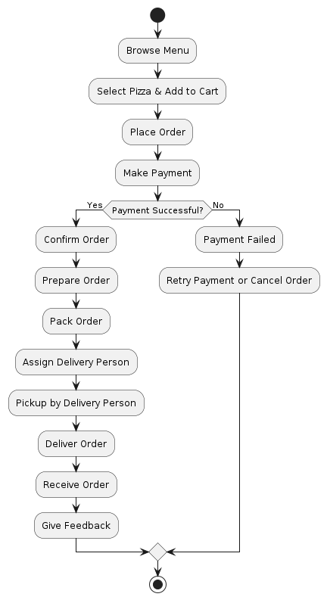

* Admin Activity Diagram:-

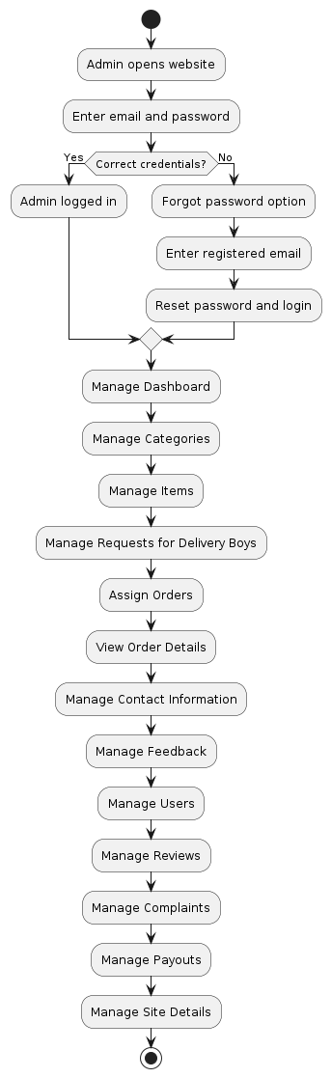

* Delivery Person activity Diagram:-

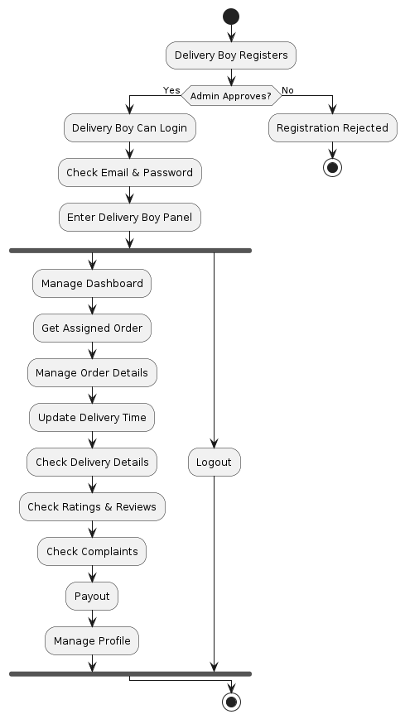

* Visitor activity Diagram:-

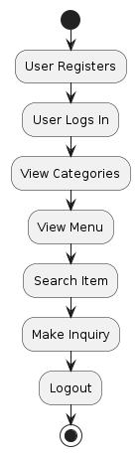

**6**

Chapter

# 6. System Diagram

|  |  |
| --- | --- |
| 6.1 | Table Structure |
| 6.2 | Screen Layout |

## 6.1 Table Structure

* **Table-name:** Admin

**Use**:- The **admin** table stores administrator details, including login

credentials, profile information, and status, for managing the system.

|  |  |  |  |
| --- | --- | --- | --- |
| Field | Type | Constraints | Description |
| id | int(21) | Primary Key (AutoIncrement) | Unique field. |
| adminName | varchar(21) | Not null | Admin name |
| profilePic | varchar(255) | NULL | Profile picture |
| email | varchar(35) | Not null, Unique | Admin email |
| phone | bigint(20) | Not null | Phone number |
| password | varchar(255) | Not null | Password |
| joinDate | datetime | Not null, Default: current_timestamp() | Joining date |
| status | enum('active','inactive') | Not null, Default: 'active' | Account status |

* **Table-name:** categories

**Use**: This table stores different categories of pizzas, such as Veg, Non-Veg, Cheese Lovers, etc. It helps organize pizzas into groups, making browsing easier for users.

|  |  |  |  |
| --- | --- | --- | --- |
| Field | Type | Constraints | Description |
| categorieId | int(12) | Primary Key (AutoIncrement) | Unique field. |
| categorieName | varchar(255) | Not null | Category name |
| categorieImage | varchar(255) | NULL | Category image |
| categorieDesc | text | Not null | Category description |
| categorieCreateDate | datetime | Not null, Default: current_timestamp() | Created date |
| status | enum('active','inactive') | Not null, Default: 'active' | Category status |

* **Table-name:** contact

**Use**: This table records customer inquiries or complaints submitted through the contact form. It links the message to a userId and optionally to an orderId if the issue is order-related.

|  |  |  |  |
| --- | --- | --- | --- |
| Field | Type | Constraints | Description |
| contactId | int(21) | Primary Key (AutoIncrement) | Unique field. |
| userId | int(21) | Not null, Foreign Key (users.id) | User reference |
| email | varchar(35) | Not null | User email |
| phoneNo | bigint(21) | Not null | Phone number |
| orderId | int(21) | Not null, Default: 0 | If issue is order-related, store orderId, else 0 |
| message | text | Not null | User message |
| time | datetime | Not null, Default: current_timestamp() | Contact time |
| status | enum('new','resolved') | Not null, Default: 'new' | Message status |

* **Table-name:** contactreply

**Use**: Stores replies from the admin or support team to customer inquiries. It links back to the contactI

|  |  |  |  |
| --- | --- | --- | --- |
| Field | Type | Constraints | Description |
| id | int(21) | Primary Key (AutoIncrement) | Unique field. |
| contactId | int(21) | Not null, Foreign Key (contact.contactId) | Contact reference |
| userId | int(21) | Not null, Foreign Key (users.id) | User reference |
| message | text | Not null | Reply message |
| datetime | datetime | Not null, Default: current_timestamp() | Reply time |

* **Table-name:** delivery_boys

**Use**: Maintains information about delivery personnel, including their login credentials, vehicle type, and status. It helps in assigning orders to delivery agents.

|  |  |  |  |
| --- | --- | --- | --- |
| Field | Type | Constraints | Description |
| id | int(11) | Primary Key (AutoIncrement) | Unique field. |
| delivery_boy_name | varchar(50) | Not null | Full name |
| first_name | varchar(50) | Not null | First name |
| last_name | varchar(50) | Not null | Last name |
| email | varchar(100) | Not null, Unique | Email |
| phone | varchar(15) | Not null, Unique | Phone number |
| password | varchar(255) | Not null | Password |
| vehicle_type | varchar(3) | NULL | Vehicle type |
| status | enum('pending','approved','rejected') | Default: 'pending' | Account status |
| created_at | timestamp | Not null, Default: current_timestamp() | Created time |

* **Table-name:** feedback

**Use**: Stores customer feedback, including email, rating (1-5), and optional comments. This helps in analyzing customer satisfaction.

|  |  |  |  |
| --- | --- | --- | --- |
| Field | Type | Constraints | Description |
| feedback_id | int(11) | Primary Key (AutoIncrement) | Unique feedback ID. |
| user_id | int(11) | Foreign Key | User ID who provided feedback. |
| rating | enum('1','2','3','4','5') | Not null | Rating provided by the user. |
| comment | text | Not null | Comment provided by the user. |
| submission_date | datetime | Default current_timestamp() | Date when the feedback was submitted. |
| status | enum('pending','approved','rejected') | Default 'pending' | Feedback status. |

* **Table-name:** items

**Use:** This table contains information about items available for order, including name, price, description, category, and availability status.

|  |  |  |  |
| --- | --- | --- | --- |
| Field | Type | Constraints | Description |
| itemId | int(12) | Primary Key (AutoIncrement) | Unique item ID. |
| itemName | varchar(255) | Not null | Name of the item. |
| itemImage | varchar(255) | Default NULL | Image associated with the item. |
| itemPrice | int(12) | Not null | Price of the item. |
| itemDesc | text | Not null | Description of the item. |
| itemCategorieId | int(12) | Foreign Key | Category ID the item belongs to. |
| itemPubDate | datetime | Default current_timestamp() | Date when the item was published. |
| status | enum('available','unavailable') | Default 'available' | Item availability status. |

* **Table-name:** likes

**Use**: Keeps track of pizzas liked by users, allowing the website to show

trending or most-liked pizzas.

|  |  |  |  |
| --- | --- | --- | --- |
| Field | Type | Constraints | Description |
| id | int(11) | Primary Key (AutoIncrement) | Unique like ID. |
| userId | int(11) | Foreign Key | User ID who liked the item. |
| itemId | int(11) | Foreign Key | Item ID that was liked. |
| created_at | timestamp | Default current_timestamp() | Date when the like was made. |

* **Table-name:** orderitems

**Use**: Stores details of individual items within an order, including the pizza ordered, quantity, size, and availability status.

|  |  |  |  |
| --- | --- | --- | --- |
| Field | Type | Constraints | Description |
| id | int(21) | Primary Key (AutoIncrement) | Unique order item ID. |
| orderId | int(21) | Foreign Key | Order ID the item belongs to. |
| itemId | int(21) | Foreign Key | Item ID included in the order. |
| itemQuantity | int(100) | Not null | Quantity of the item in the order. |
| size | varchar(255) | Default 'M' | Size of the item ordered. |
| status | enum('available','out_of_stock') | Default 'available' | Item stock status. |

* **Table-name:** orders

**Use**: Maintains records of customer orders, including user details, order

amount, payment method (cash or online), order status (placed, confirmed,delivered, etc.), and assigned delivery boy.

|  |  |  |  |
| --- | --- | --- | --- |
| Field | Type | Constraints | Description |
| orderId | int(11) | Primary Key (AutoIncrement) | Unique order ID. |
| userId | int(21) | Foreign Key | User ID who placed the order. |
| address | varchar(255) | Not null | Delivery address. |
| zipCode | int(21) | Not null | Zip code of the address. |
| phoneNo | bigint(21) | Not null | Phone number for delivery. |
| amount | decimal(10,2) | Default NULL | Total order amount. |
| payment_id | varchar(100) | Default NULL | Payment transaction ID. |
| paymentMode | enum('0','1') | Not null Default '0' | Payment mode (COD or online). |
| orderStatus | enum('0','1','2','3','4','5','6') | Default '0' | Order status. |
| size | enum('S','M','L') | Default 'M' | Size selected for the order. |
| createdAt | datetime | Default current_timestamp() | Date when the order was created. |
| status | enum('pending','completed','cancelled') | Default 'pending' | Order status. |
| delivery_boy_id | int(11) | Default NULL | Delivery boy assigned to the order. |
| deliveryTime | int(11) | Default NULL | Estimated delivery time in minutes. |

* **Table-name:** reviews

**Use**: Stores customer reviews and complaints related to orders. Each review is linked to a userId and orderId, and includes a rating (1-5) and optional complaint text.

|  |  |  |  |
| --- | --- | --- | --- |
| Field | Type | Constraints | Description |
| reviewId | int(11) | Primary Key (AutoIncrement) | Unique review ID. |
| userId | int(21) | Foreign Key | User ID who gave the review. |
| orderId | int(21) | Foreign Key | Order ID related to the review. |
| rating | int(1) | Not null, CHECK (rating between 1 and 5) | Rating from 1 to 5. |
| complain | text | Default NULL | User's complaint or feedback. |
| reviewDate | datetime | Default current_timestamp() | Date when the review was posted. |
| delivery_boy_id | int(11) | Foreign Key | Delivery boy ID related to the review. |

* **Table-name:** sitedetail

**Use:** Stores website-related details like system name, email, contact numbers, and address. This is useful for website settings and customer support information.

|  |  |  |  |
| --- | --- | --- | --- |
| Field | Type | Constraints | Description |
| tempId | int(11) | Primary Key | Unique ID for the site details. |
| systemName | varchar(21) | Not null | System name of the website. |
| email | varchar(35) | Not null | Email address of the site. |
| contact1 | bigint(21) | Not null | Primary contact number. |
| contact2 | bigint(21) | Default NULL | Secondary contact number. |
| address | text | Not null | Address of the website. |
| dateTime | datetime | Default current_timestamp() | Timestamp when details were updated. |

* **Table-name:** users

**Use:** Maintains user account information, including login credentials, name,contact details, account type (user/admin), and status (active/blocked).

|  |  |  |  |
| --- | --- | --- | --- |
| Field | Type | Constraints | Description |
| id | int(21) | Primary Key (AutoIncrement) | Unique user ID. |
| username | varchar(21) | Not null | User's username. |
| firstName | varchar(21) | Not null | User's first name. |
| lastName | varchar(21) | Not null | User's last name. |
| profilePic | varchar(255) | Default NULL | User's profile picture. |
| email | varchar(35) | Not null, Unique | User's email address. |
| phone | bigint(20) | Not null, Unique | User's phone number. |
| password | varchar(255) | Not null | User's password. |
| joinDate | datetime | Default current_timestamp() | Date when the user joined. |
| status | enum('active','blocked') | Not null Default 'active' | User status. |

* **Table-name:** viewcart

**Use**: Stores items added to the shopping cart by users before placing an order.It tracks the pizza ID, quantity, selected size, and the user who added it.

|  |  |  |  |
| --- | --- | --- | --- |
| Field | Type | Constraints | Description |
| cartItemId | int(11) | Primary Key (AutoIncrement) | Unique cart item ID. |
| itemId | int(11) | Foreign Key | Item ID added to the cart. |
| userId | int(11) | Foreign Key | User ID who added the item. |
| quantity | int(11) | Not null | Quantity of the item in the cart. |
| size | varchar(10) | Not null | Size of the item. |
| createdAt | timestamp | Default current_timestamp() | Date when the item was added to the cart. |
| status | enum('available','out_of_stock') | Default 'available' | Item stock status. |

## 6.2 Screen Layout

* User Panel Side:-

Home Page:-

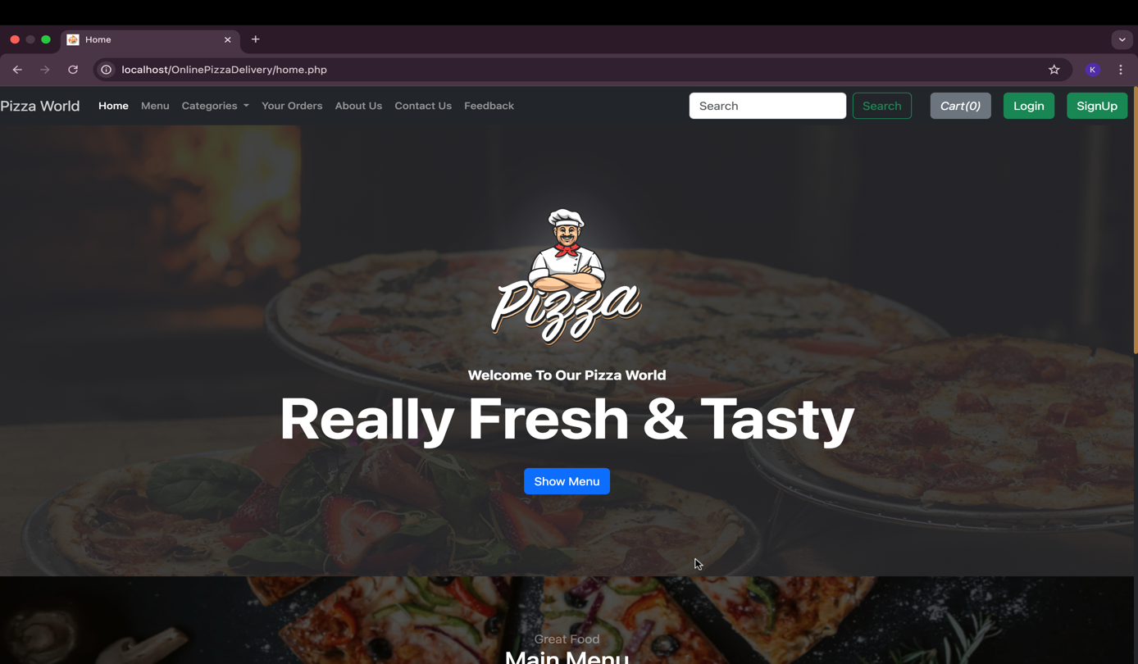

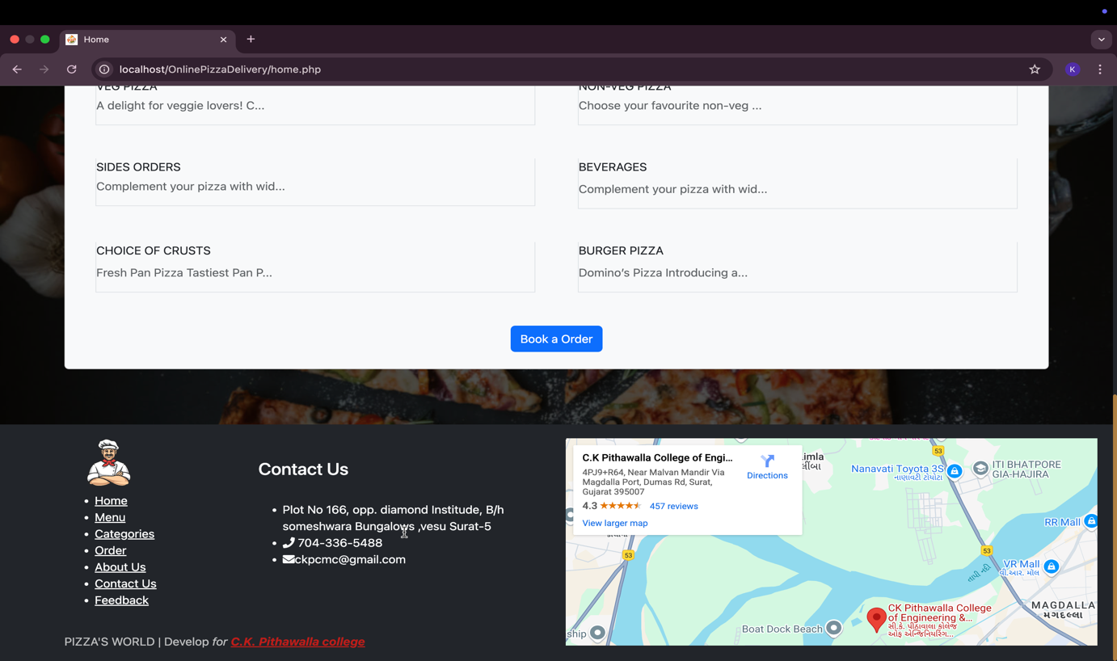

Menu Items:-

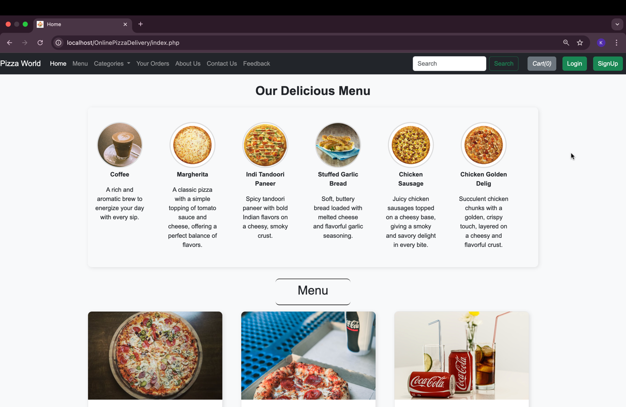

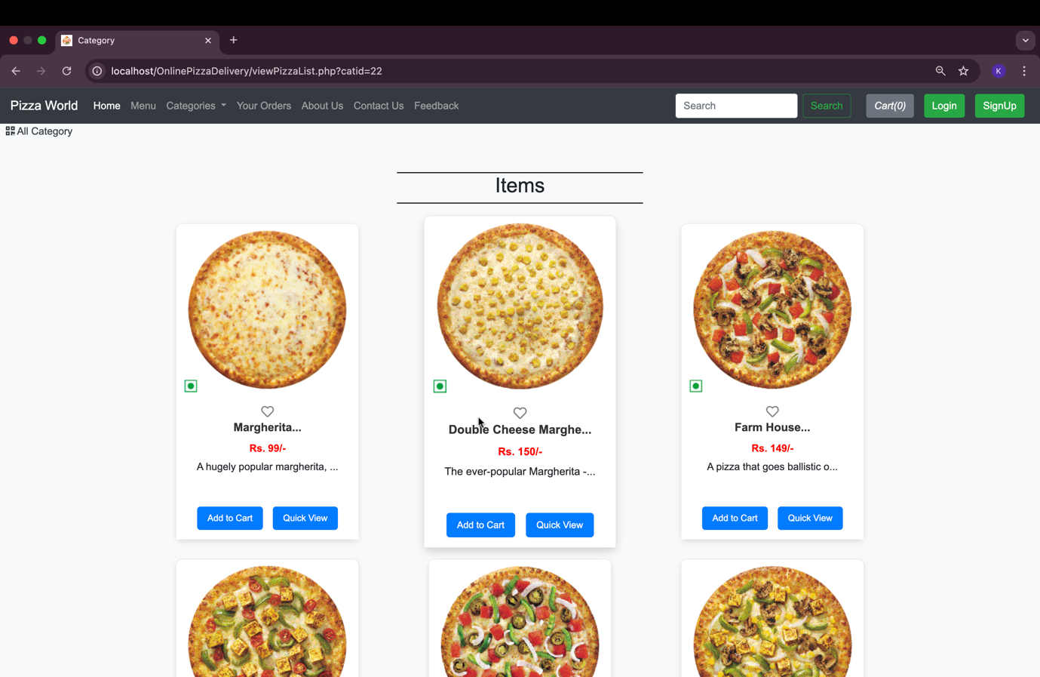

About us page:-

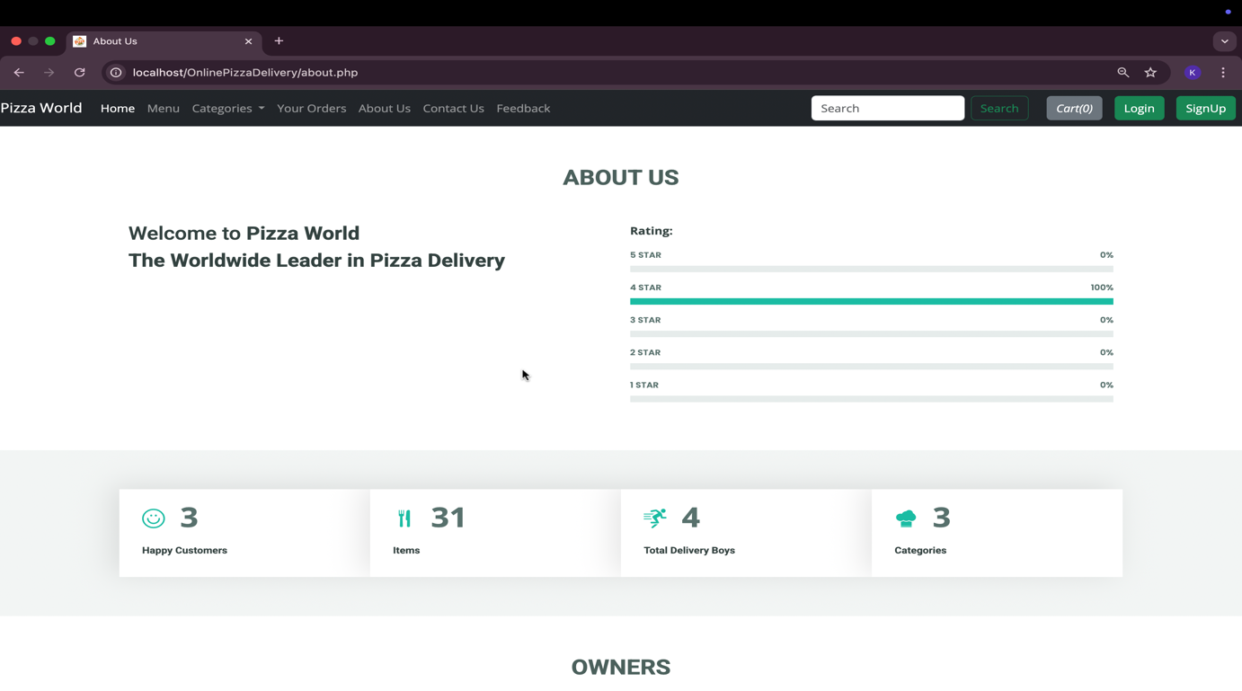

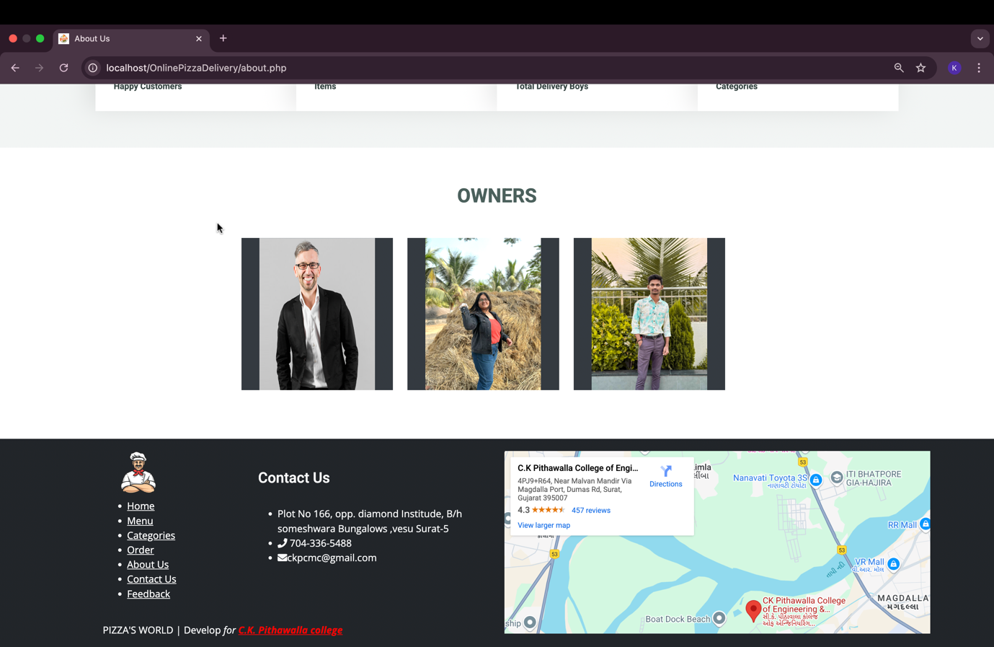

Signup:-

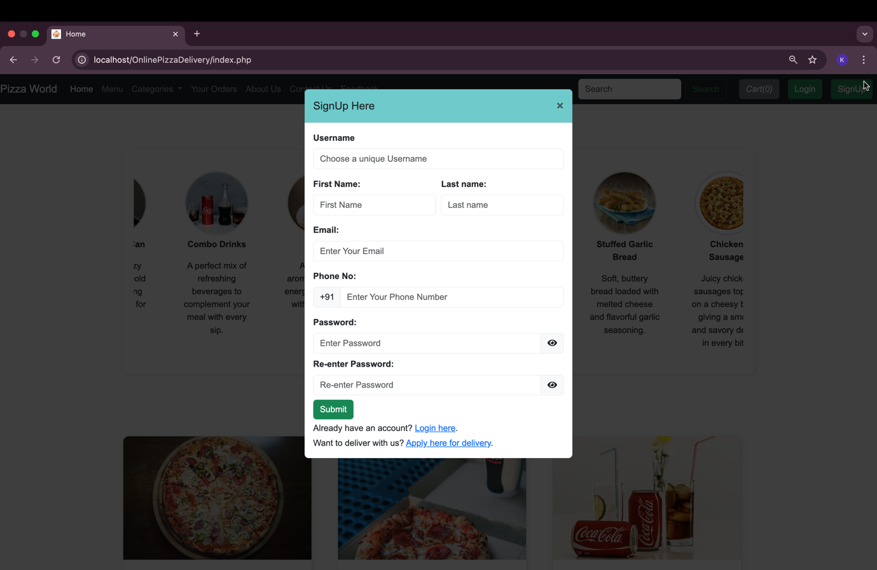

Login:-

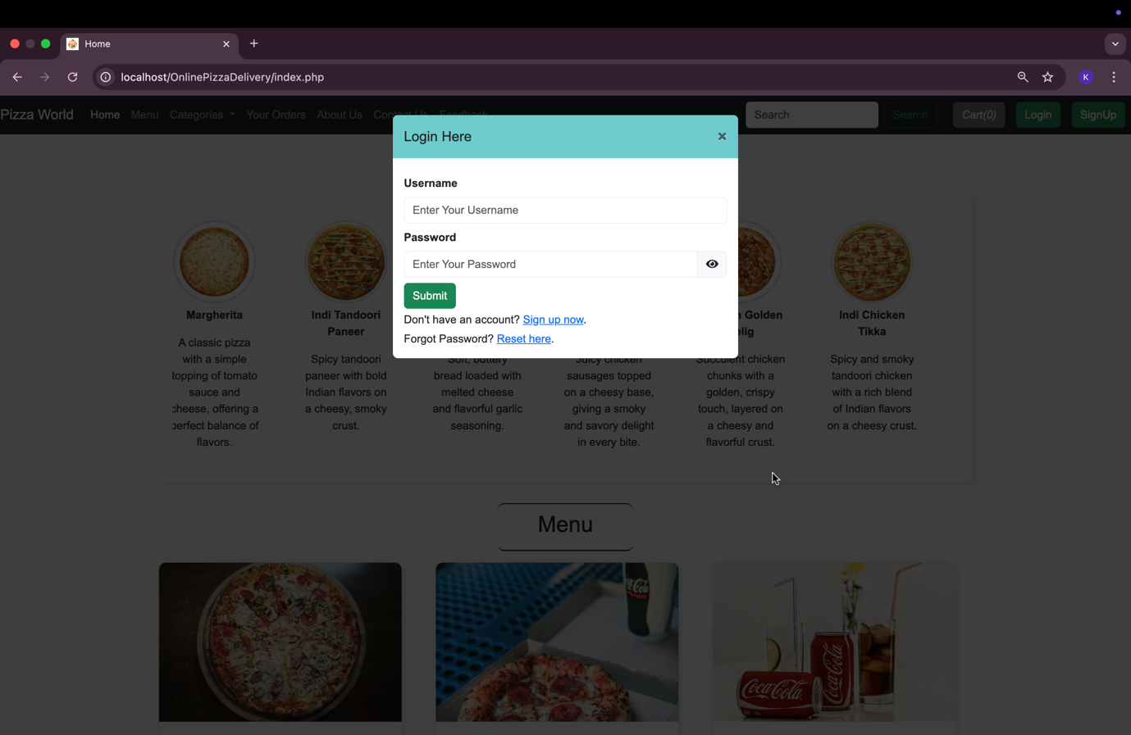

Contact us Page:-

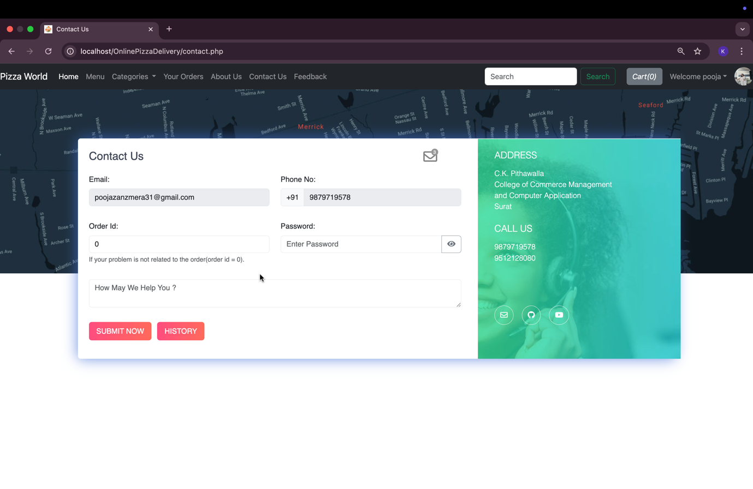

Feedback Page:-

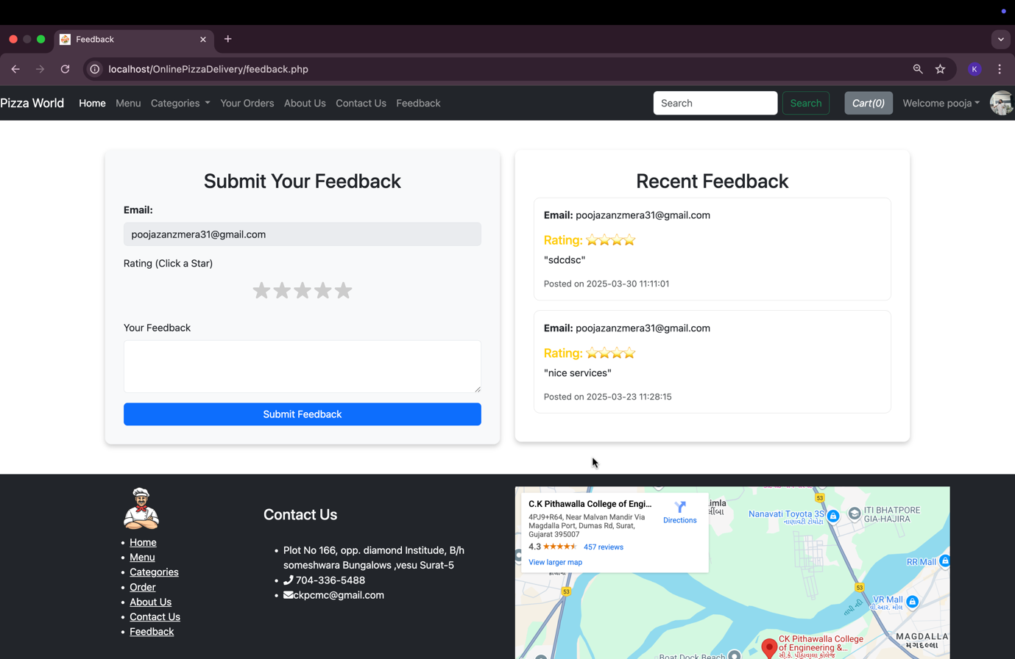

Searchig item:-

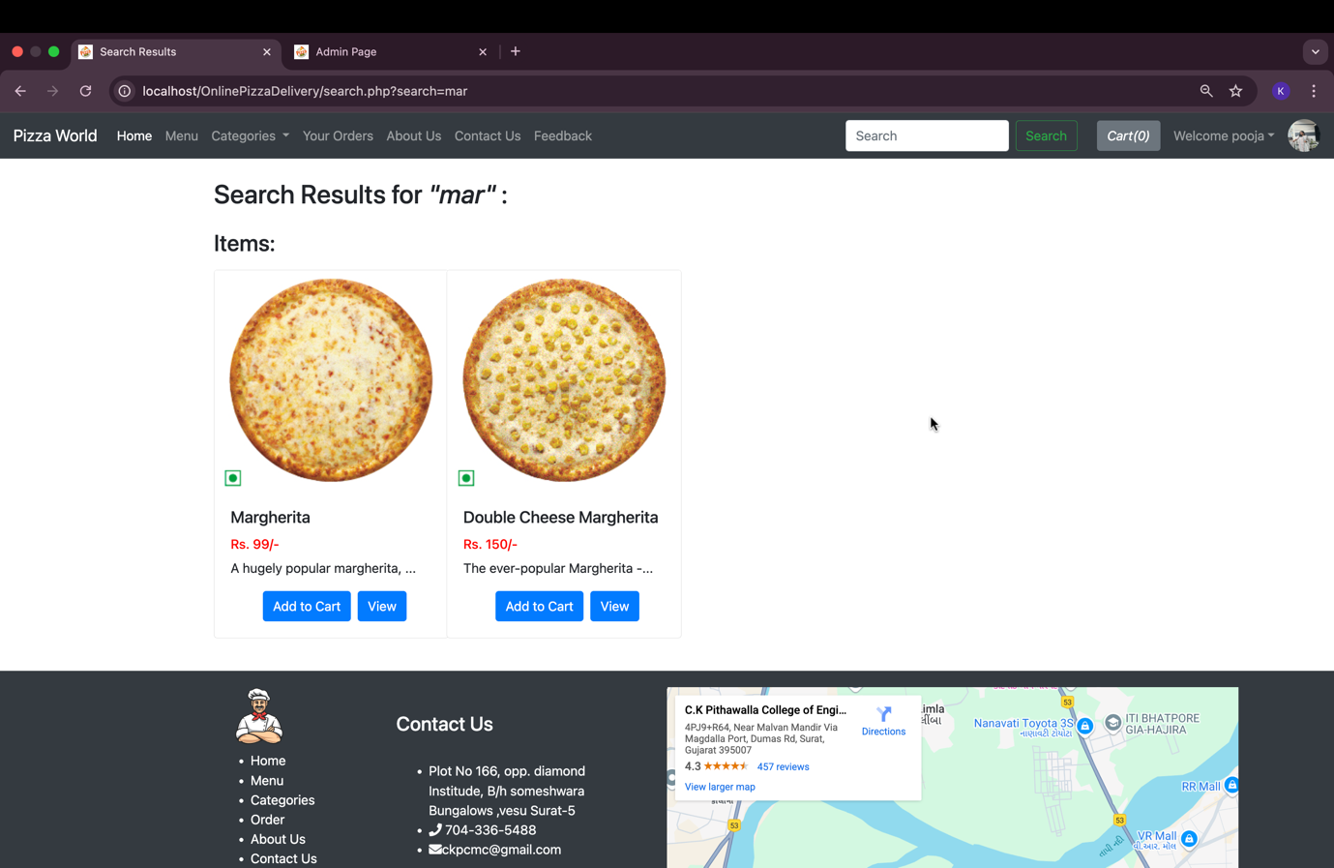

Favourite Page:-

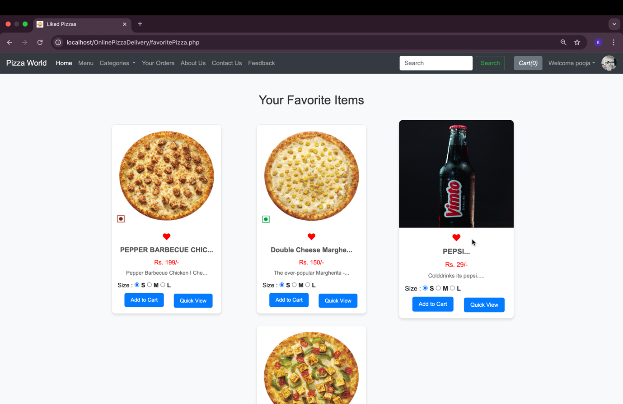

View Cart page:-

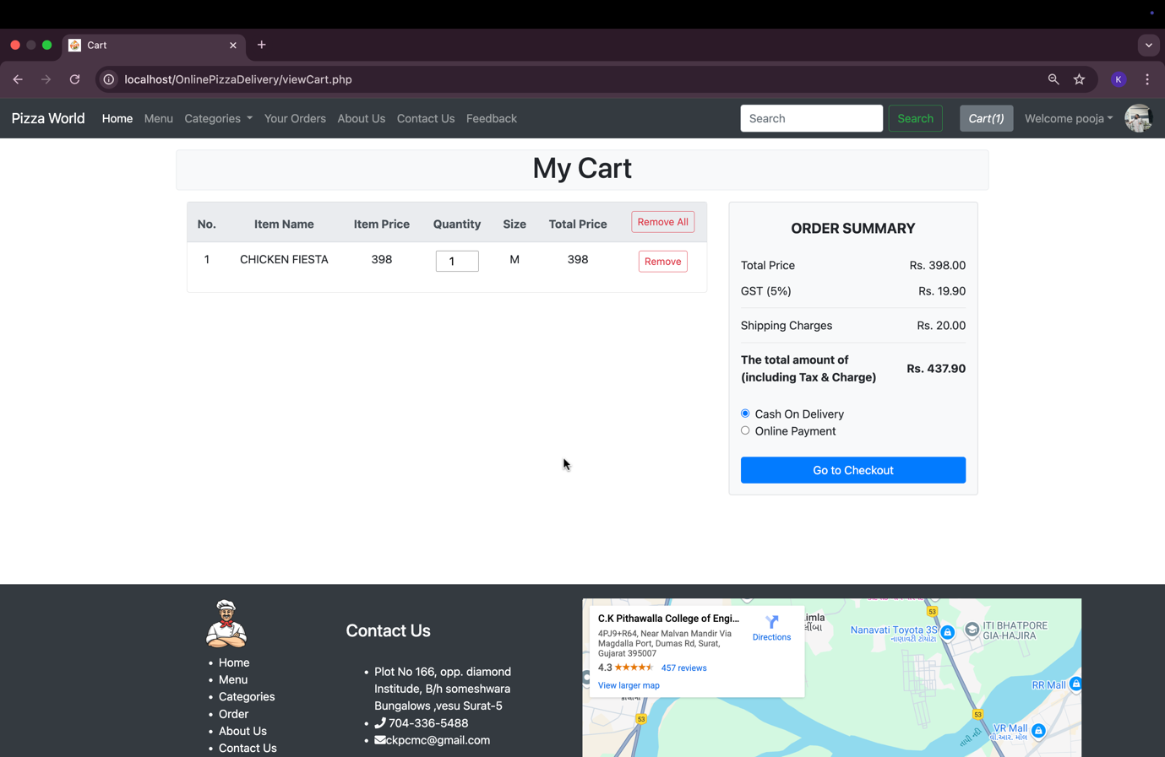

Online Payment System:-

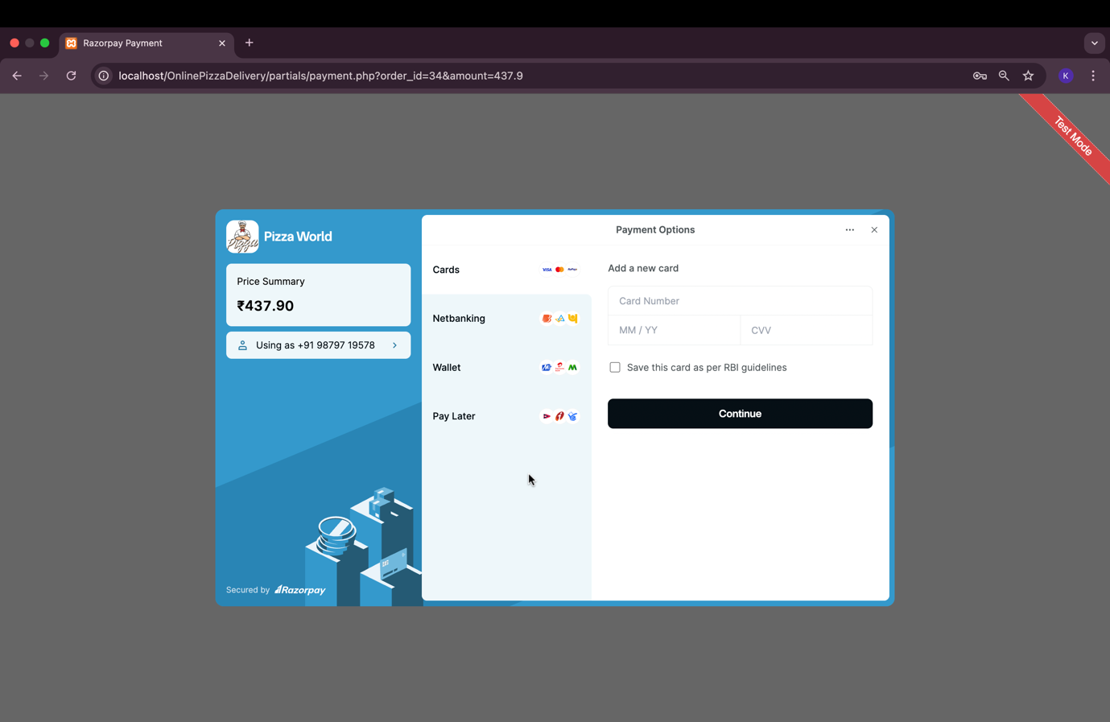

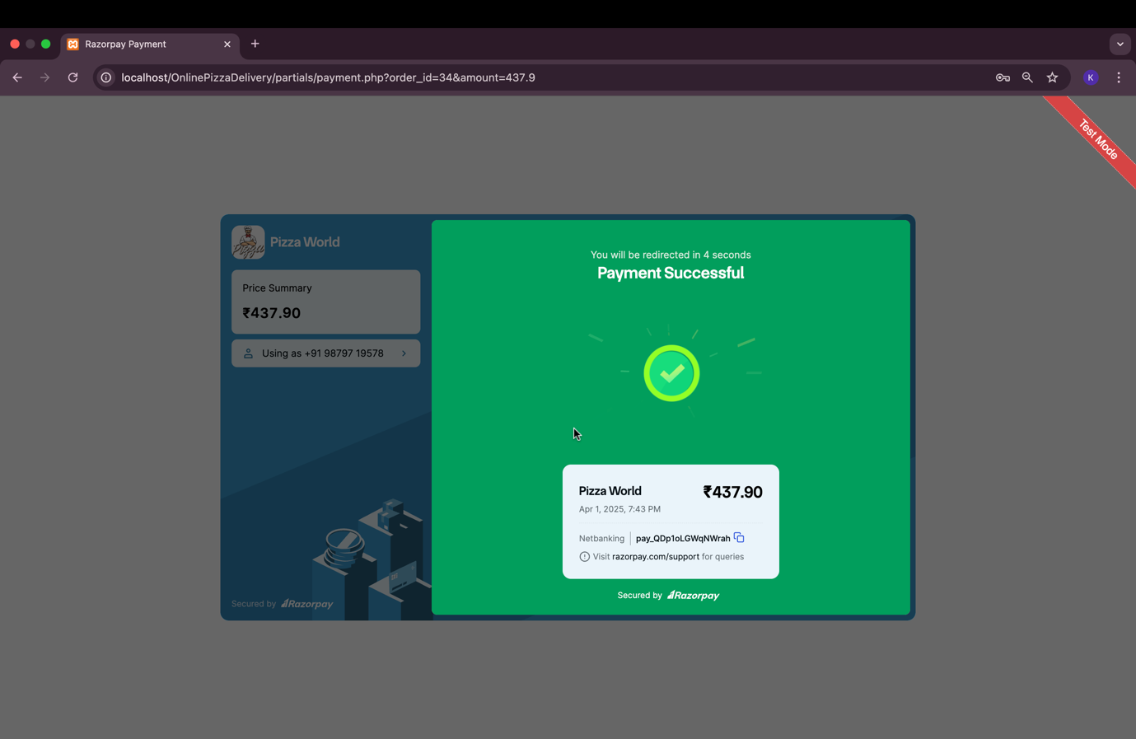

Order History:-

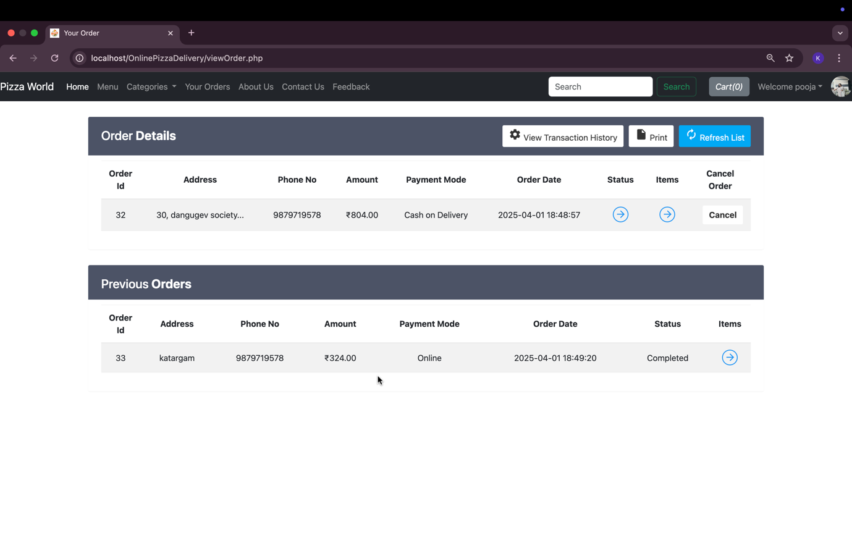

Order Status:-

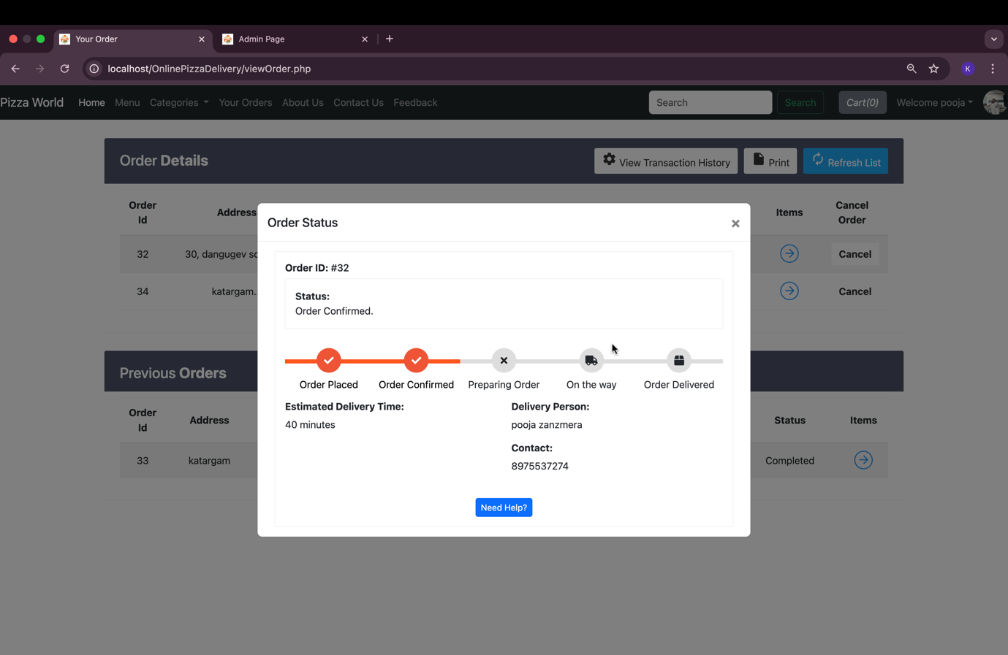

Manage Profile:-

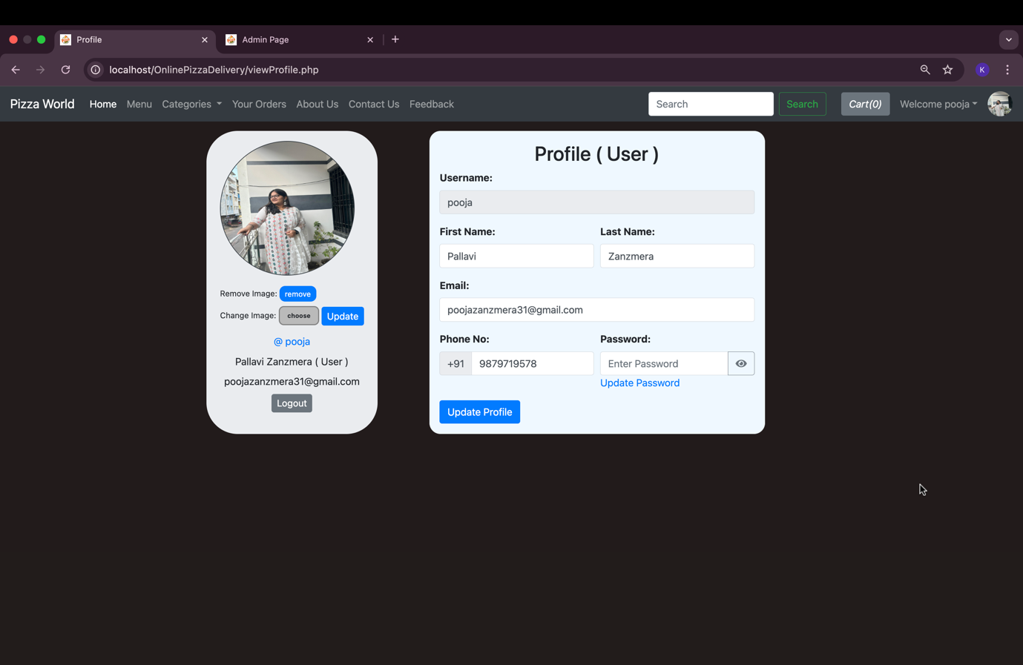

Update Password:-

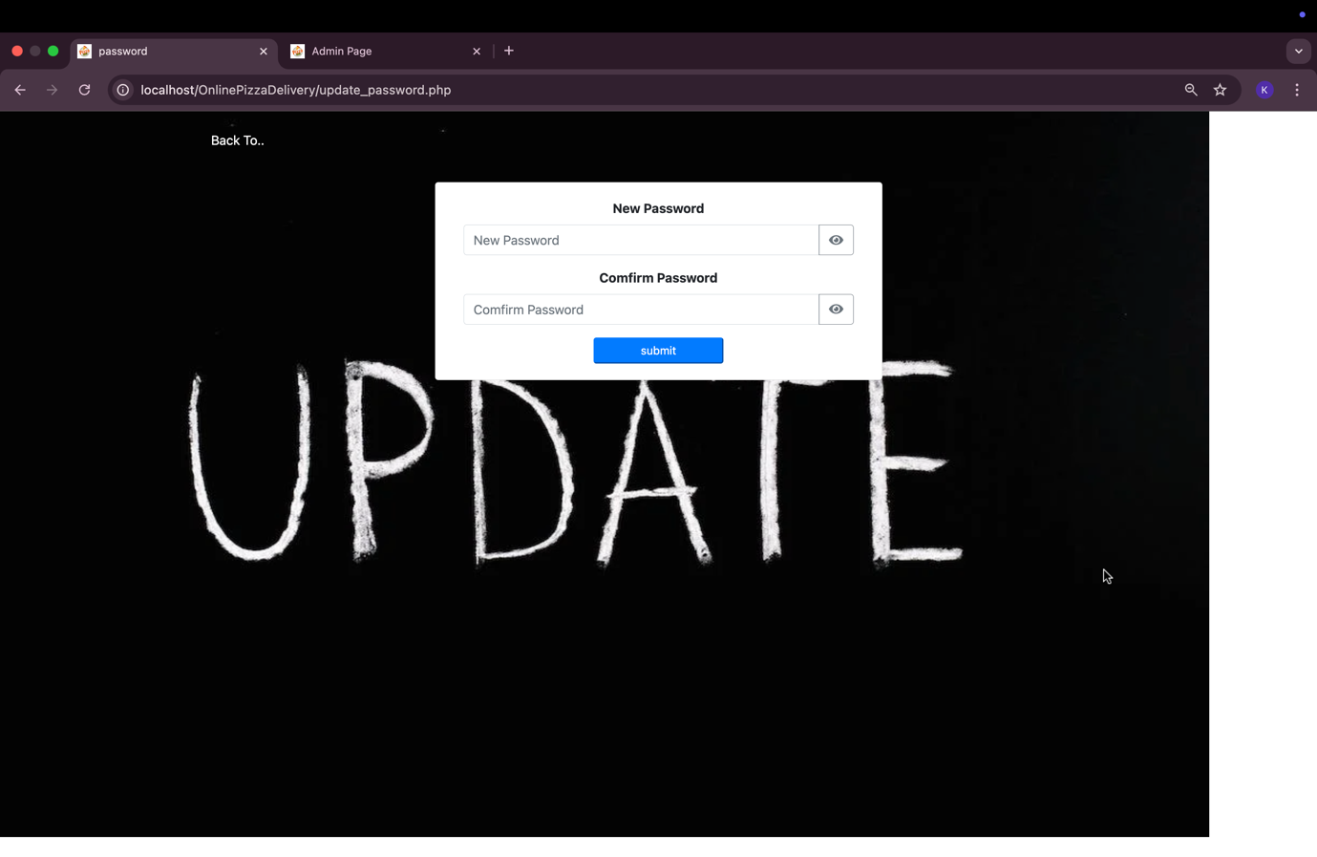

Forgot Password:-

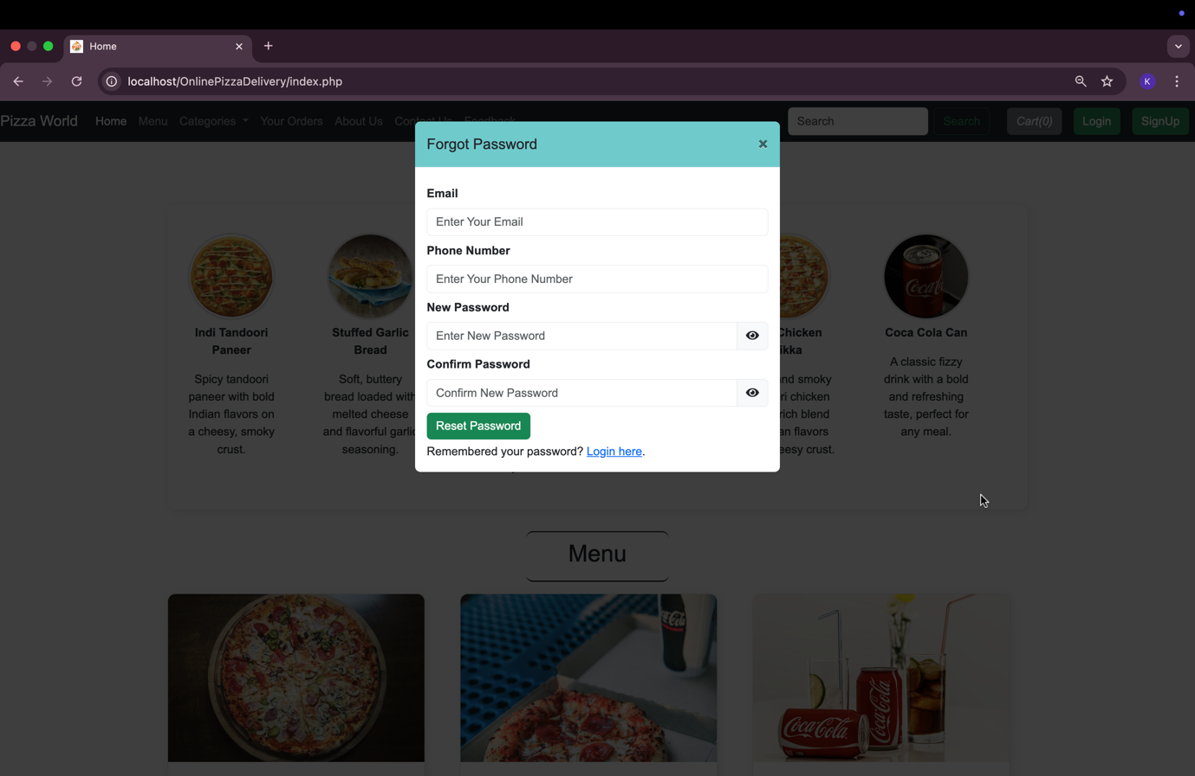

* Admin Panel side:-

Admin Login:-

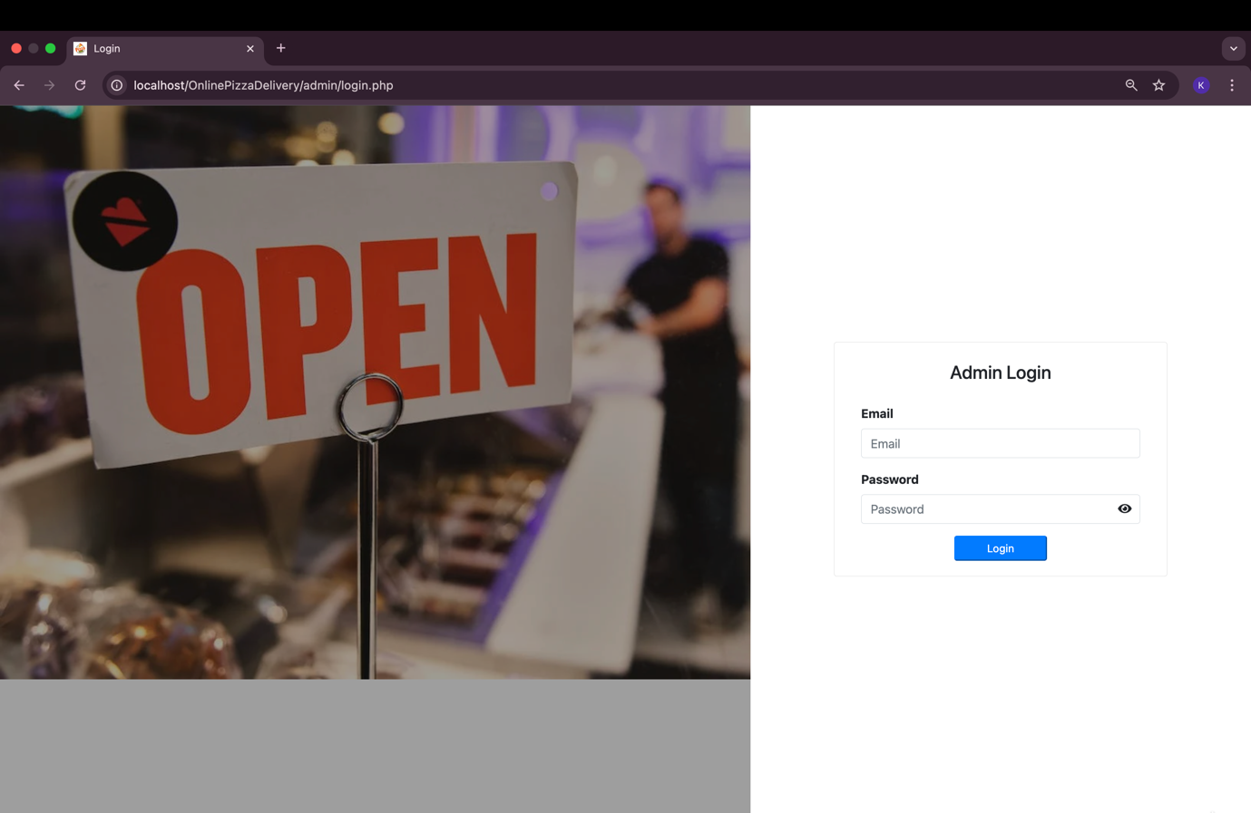

Admin DashBoard:-

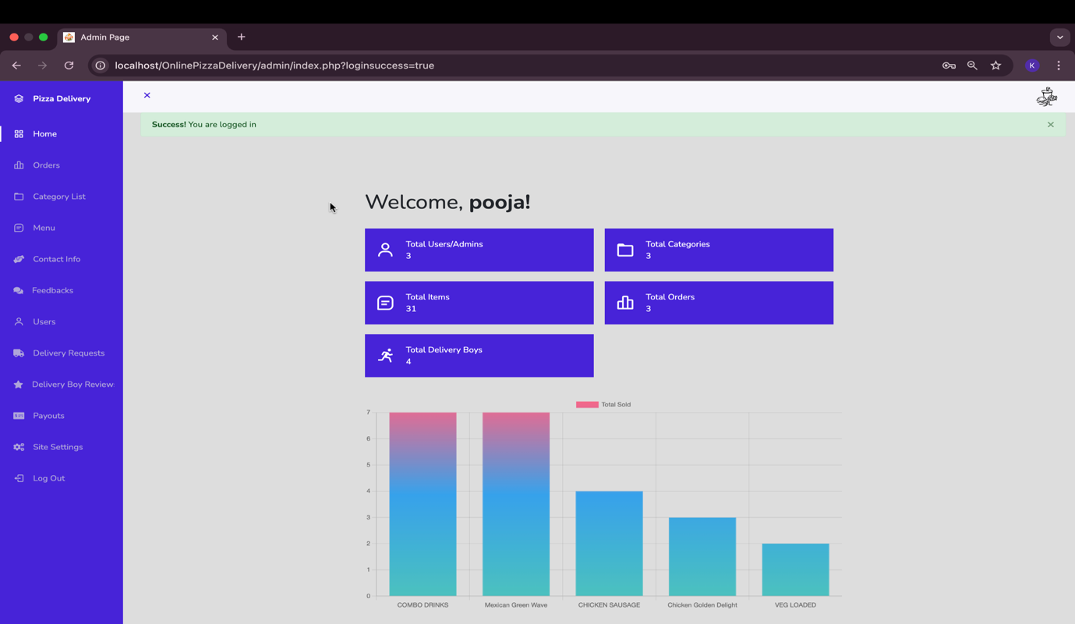

Order Details:-  
  
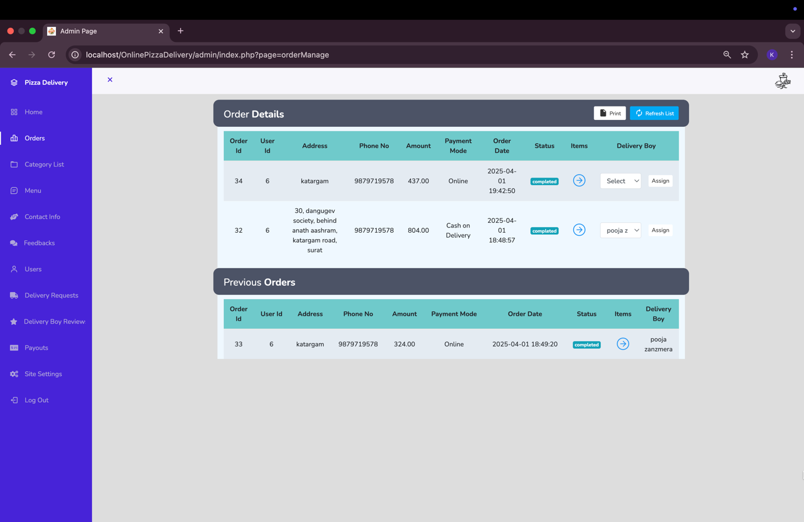

Order Items:-

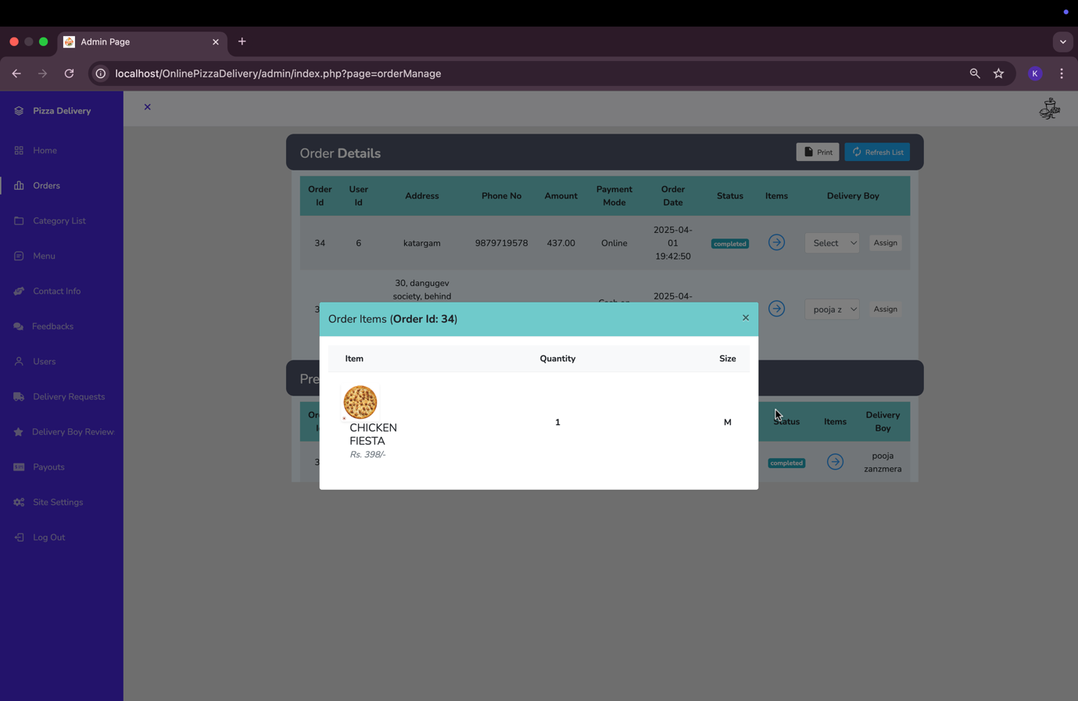

Add Category:-

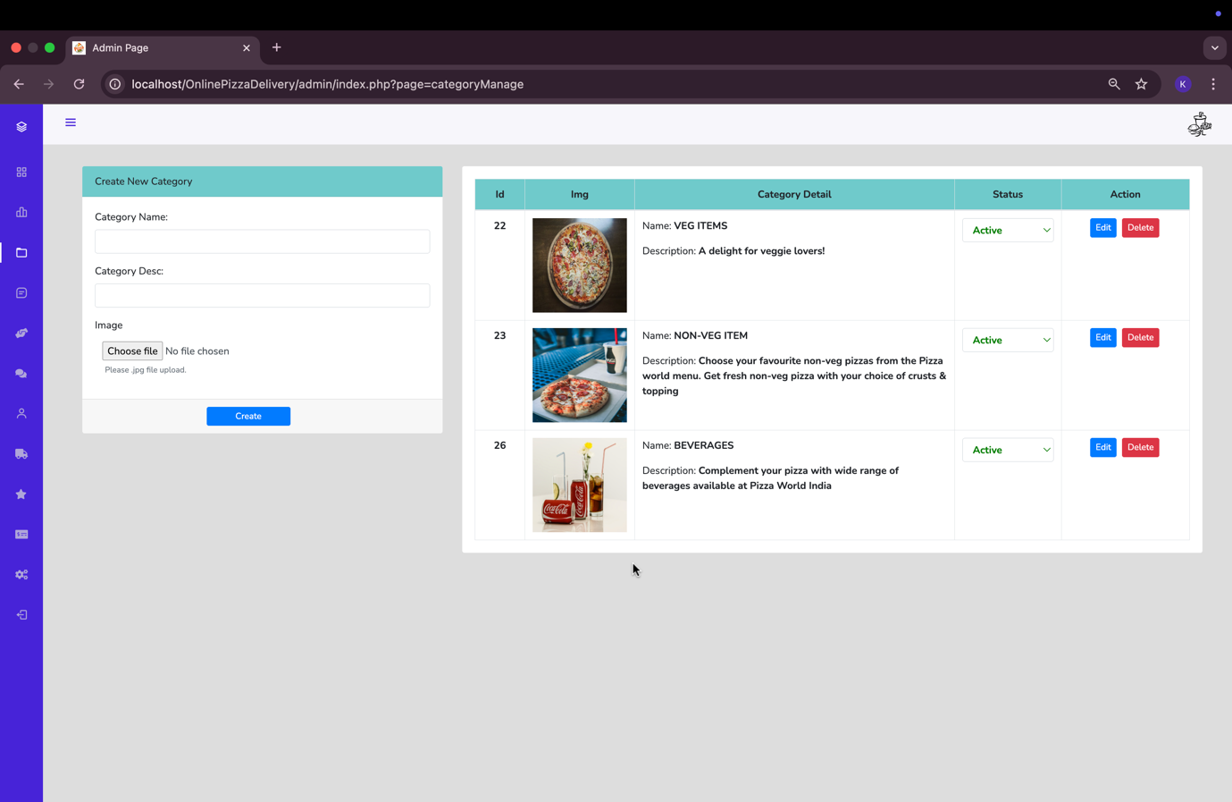

Update Category:-

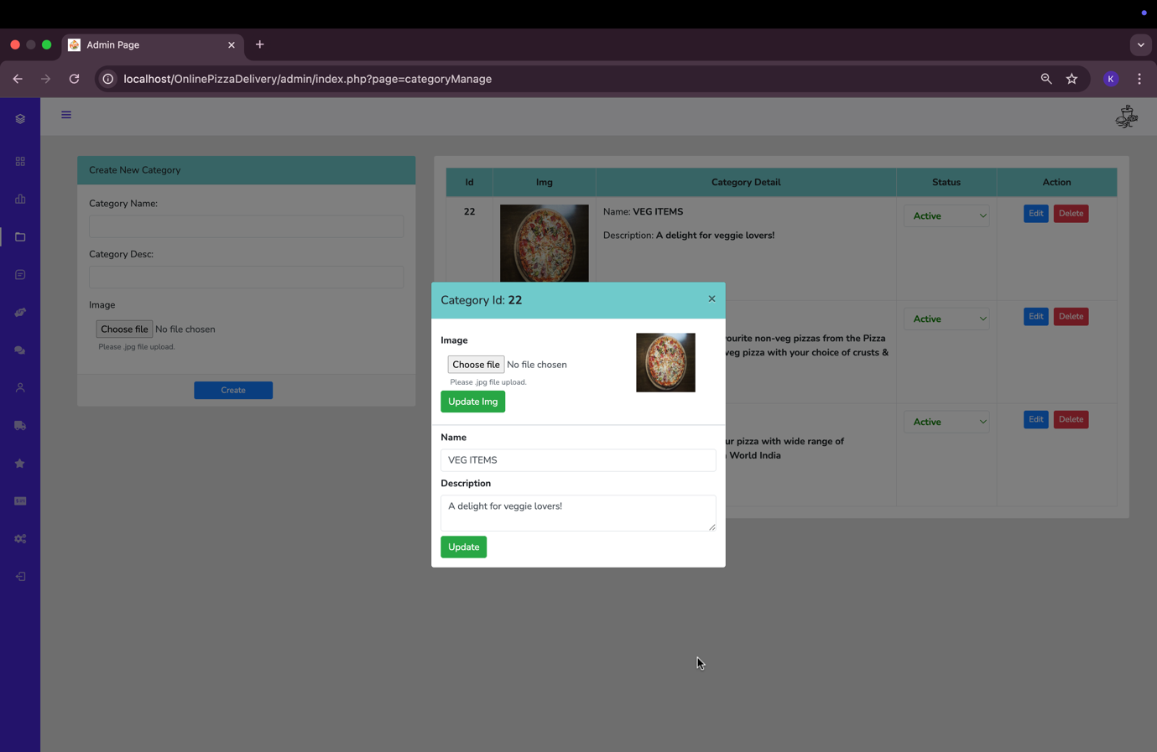

Add Item:-

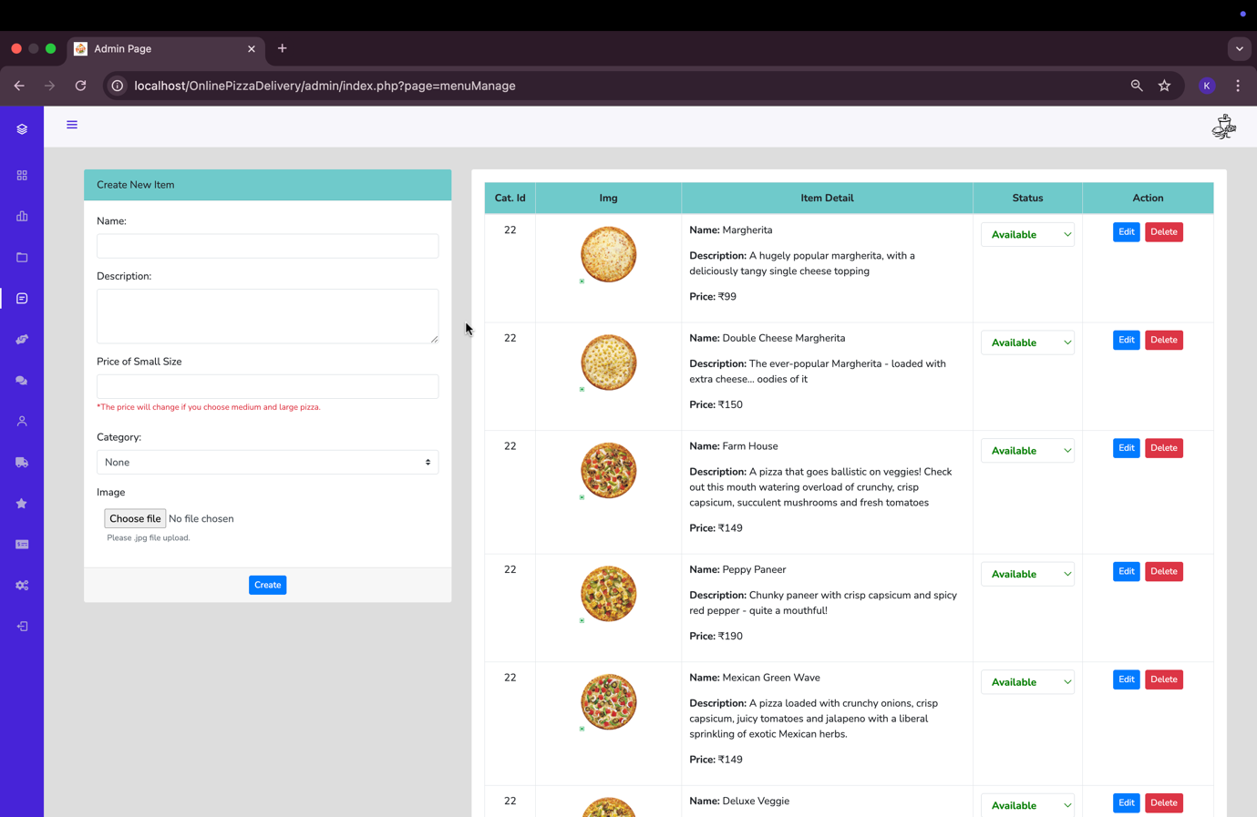

Update Item:-

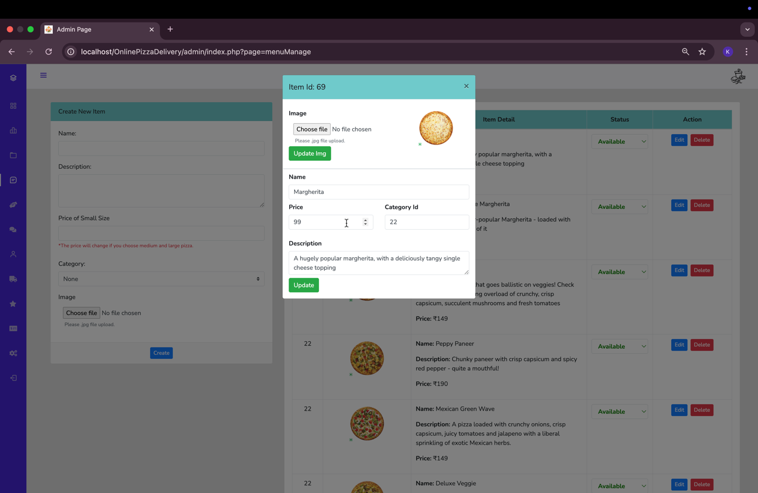

Contact US Information:-

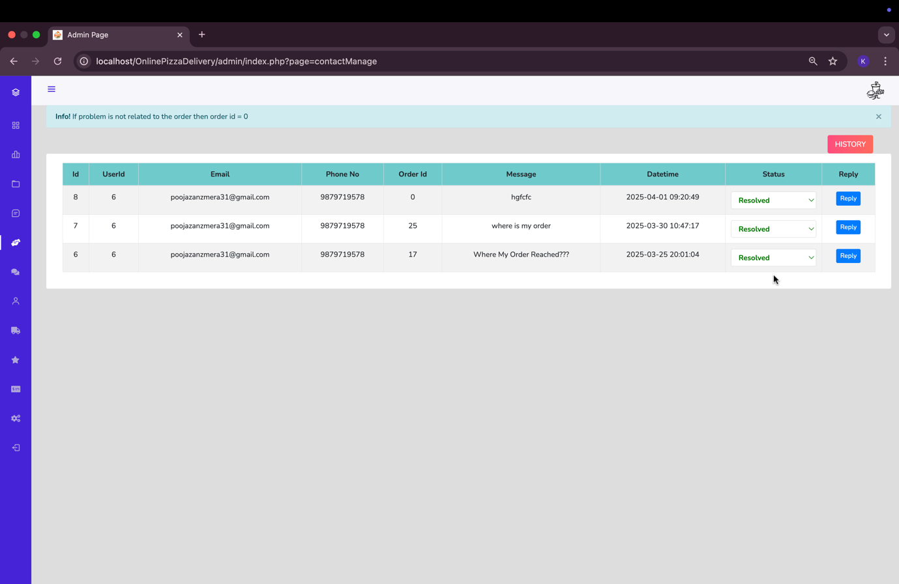

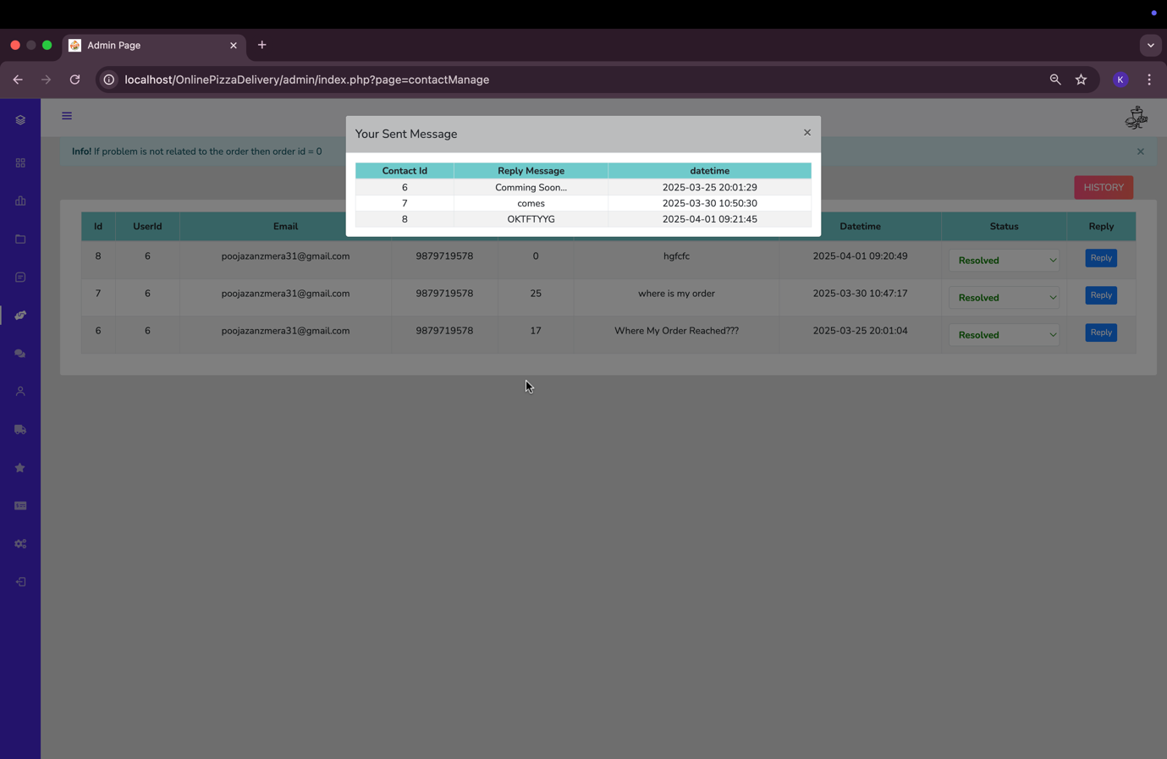

Feedbacks:-

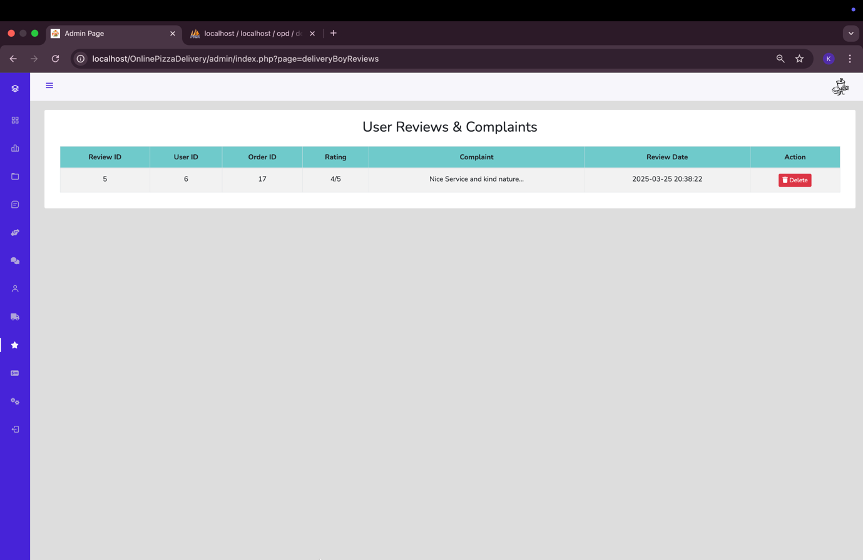

Users Information:-

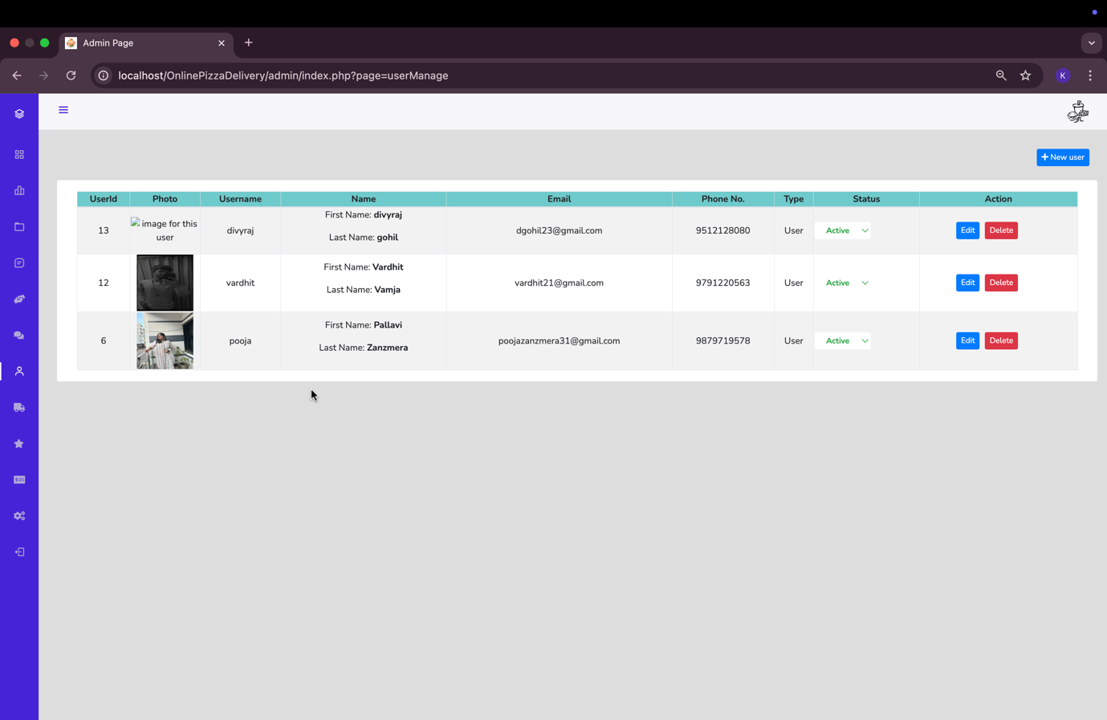

Delivery Boy Information:-

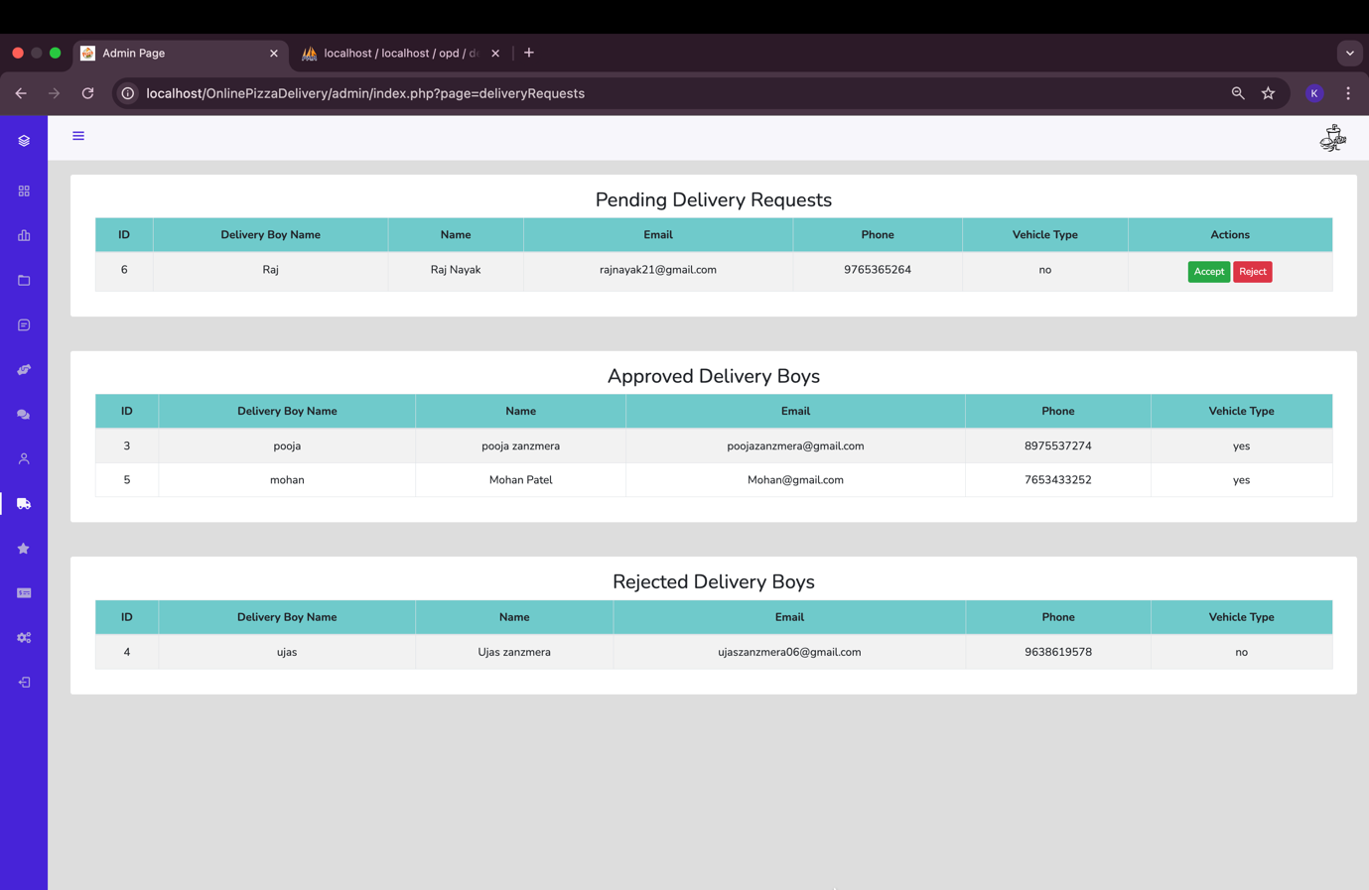

Delivery boy rate and Complaints:-

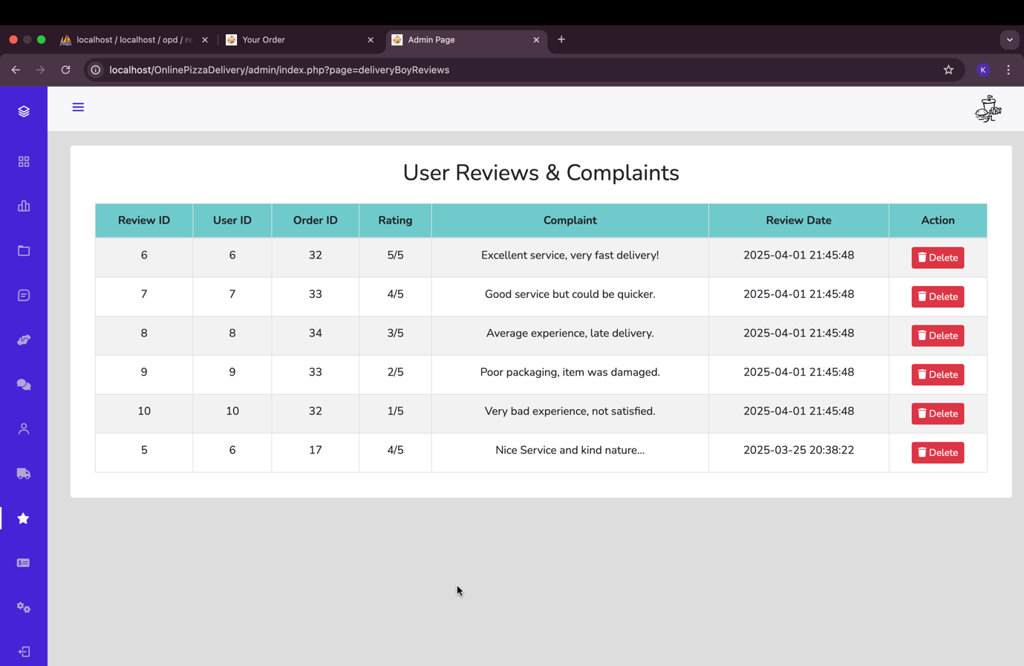

Admin Payouts per Oder:-

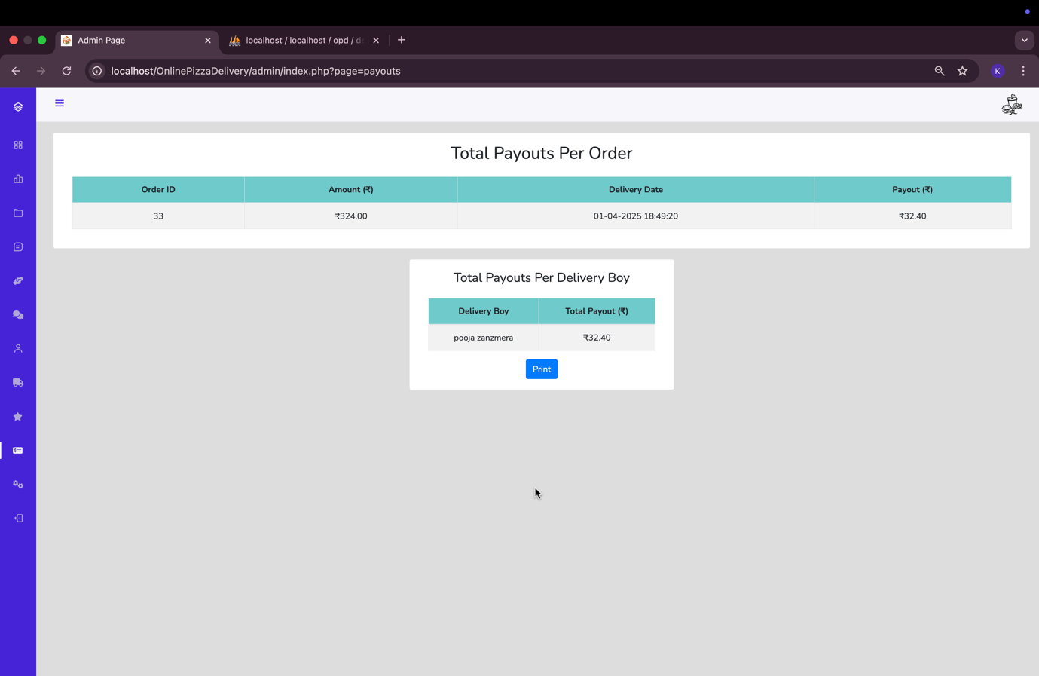

Site Details:-  
  
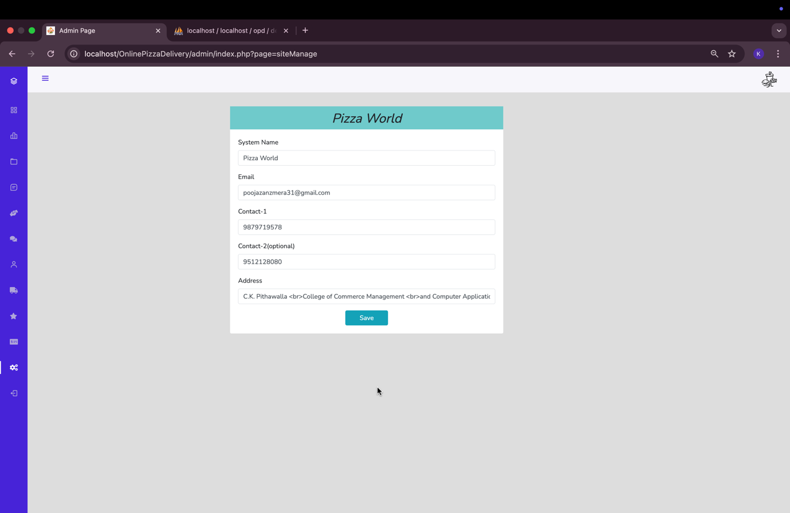

* Delivery Person Panel:-

Sign up page:-

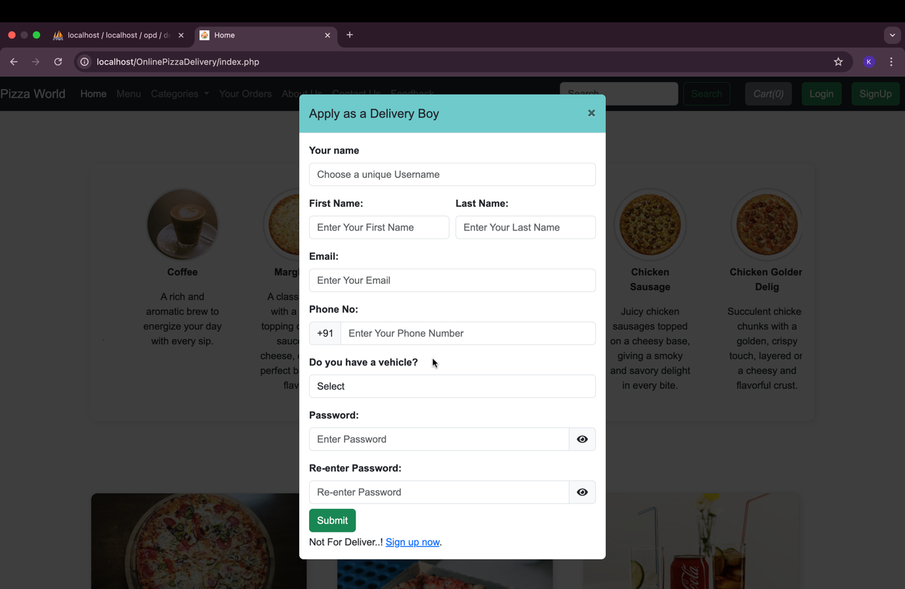

Login page:-

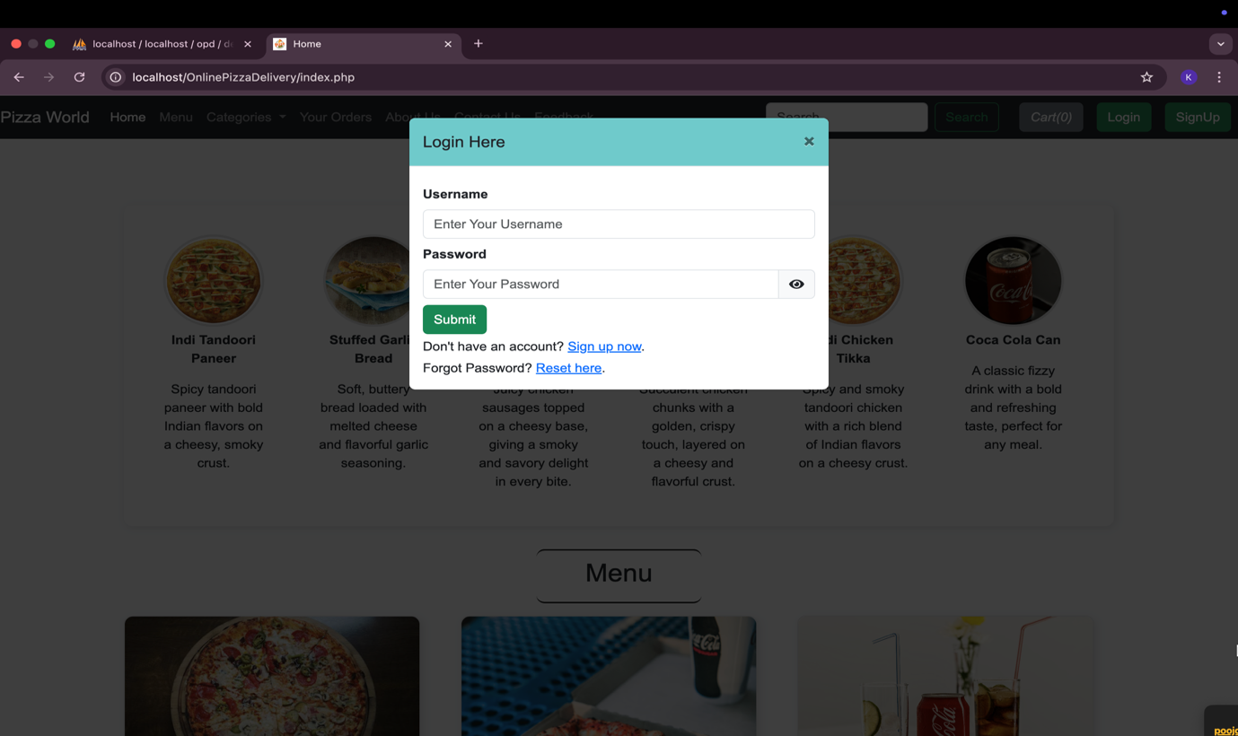

Reset Password:-

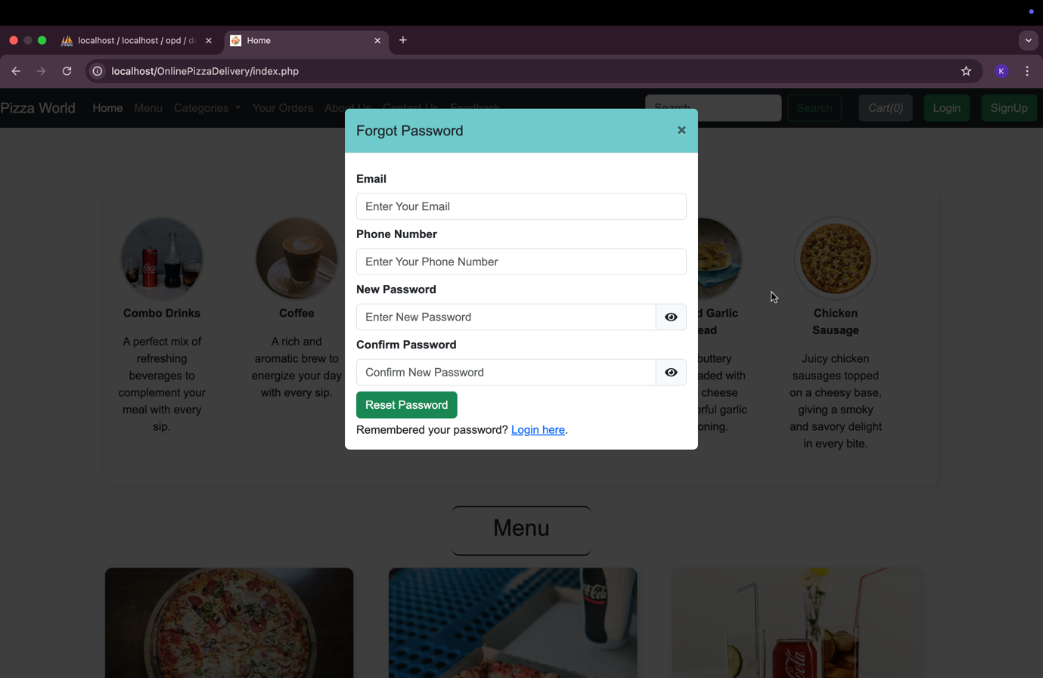

Delivery Person Dashboard:-

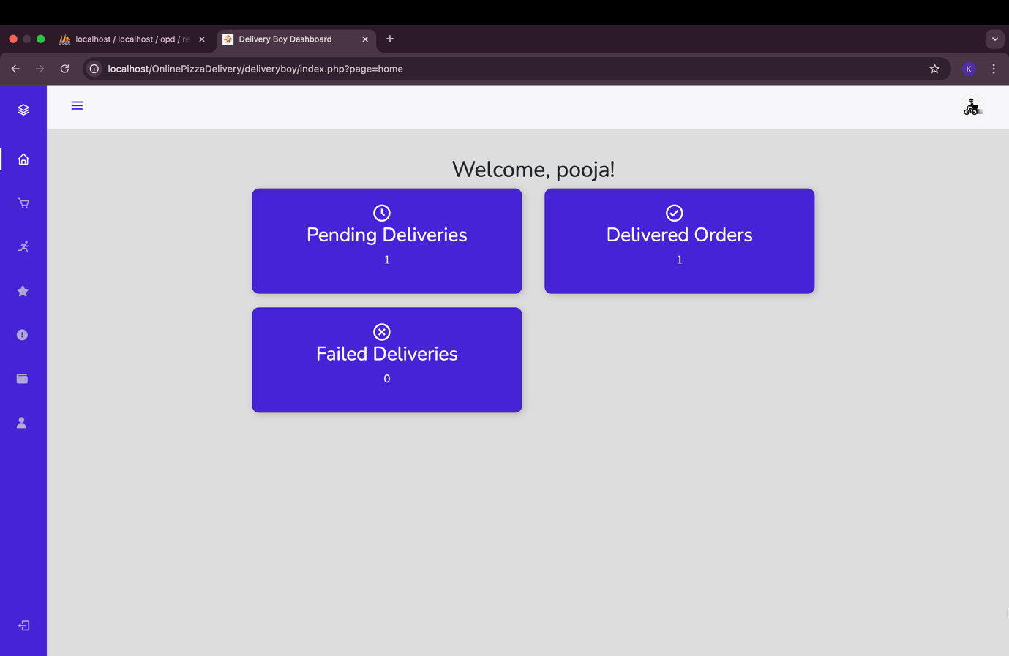

Delivery Person’s assigned order from a admin:-

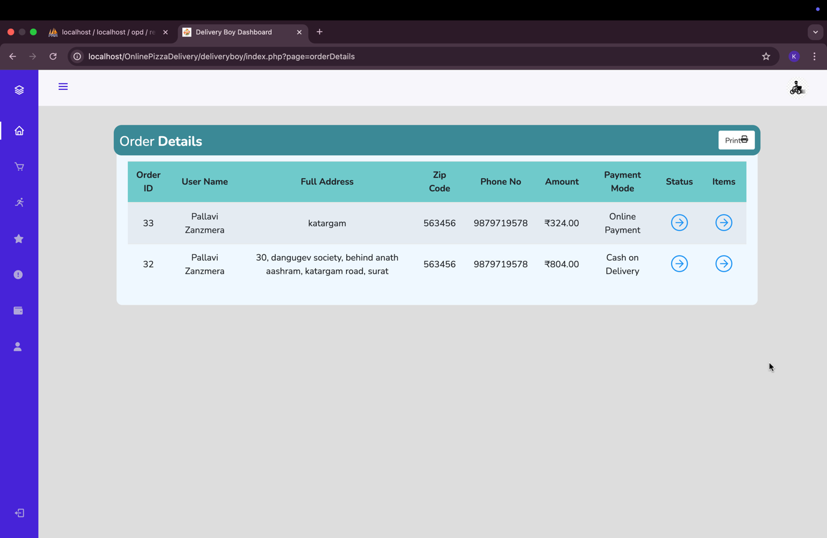

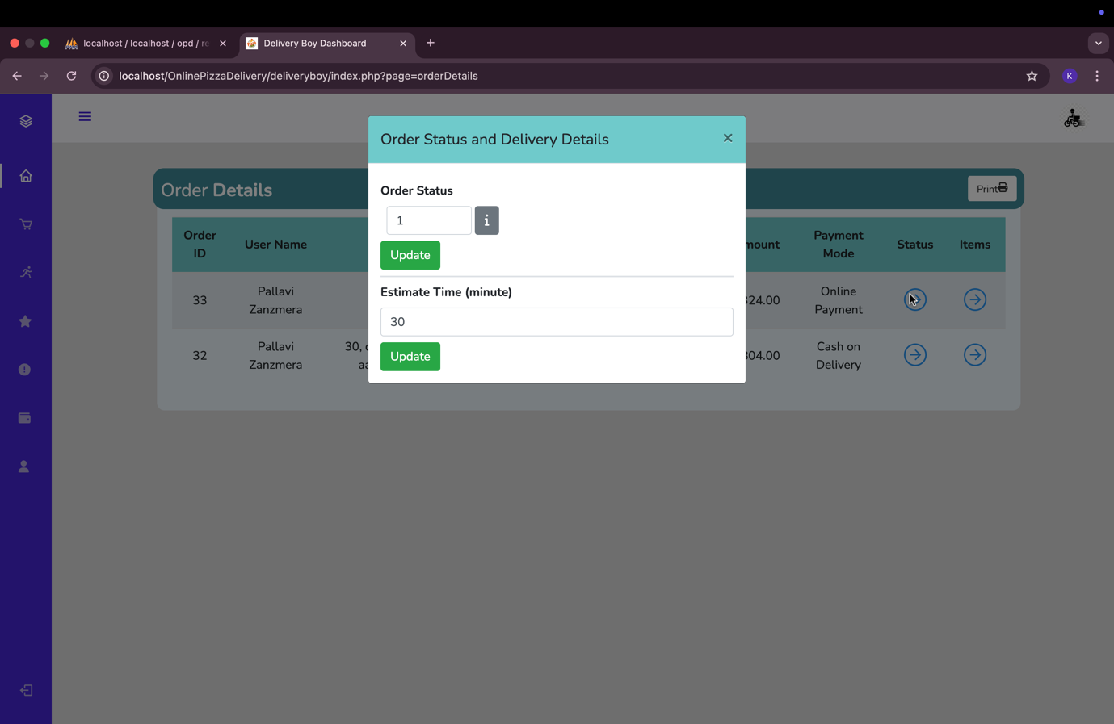

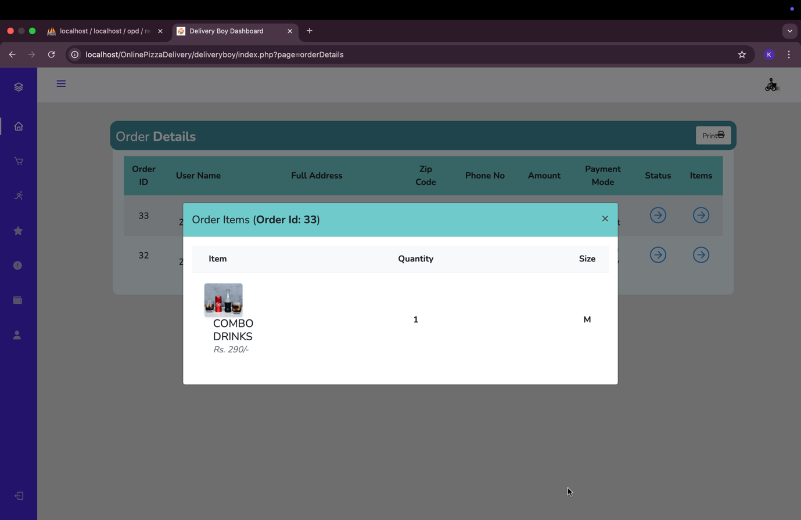

All Delivery Details:-

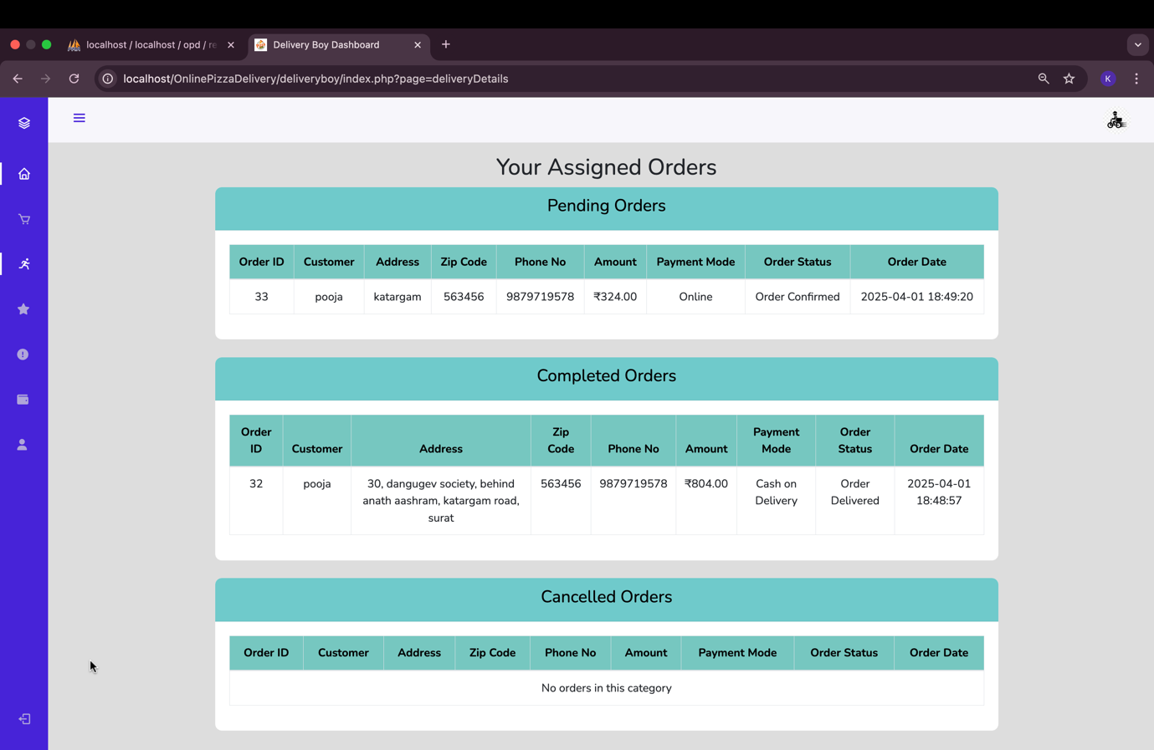

Delivery Person Rate and Complaints:-

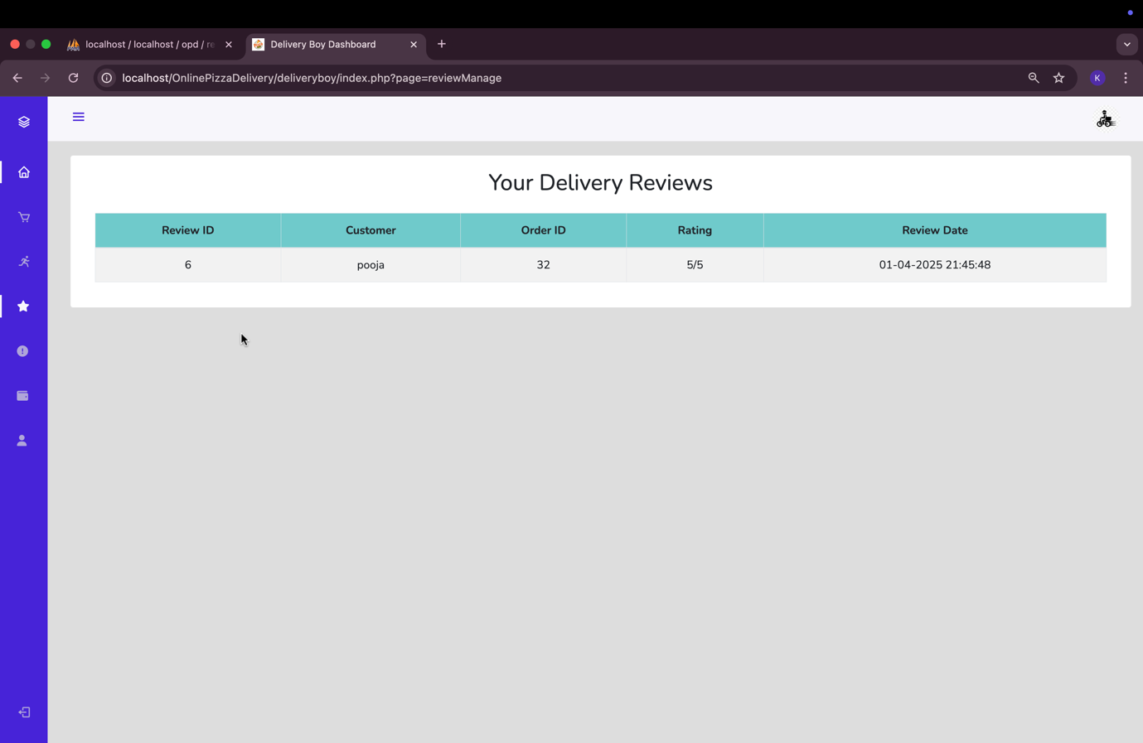

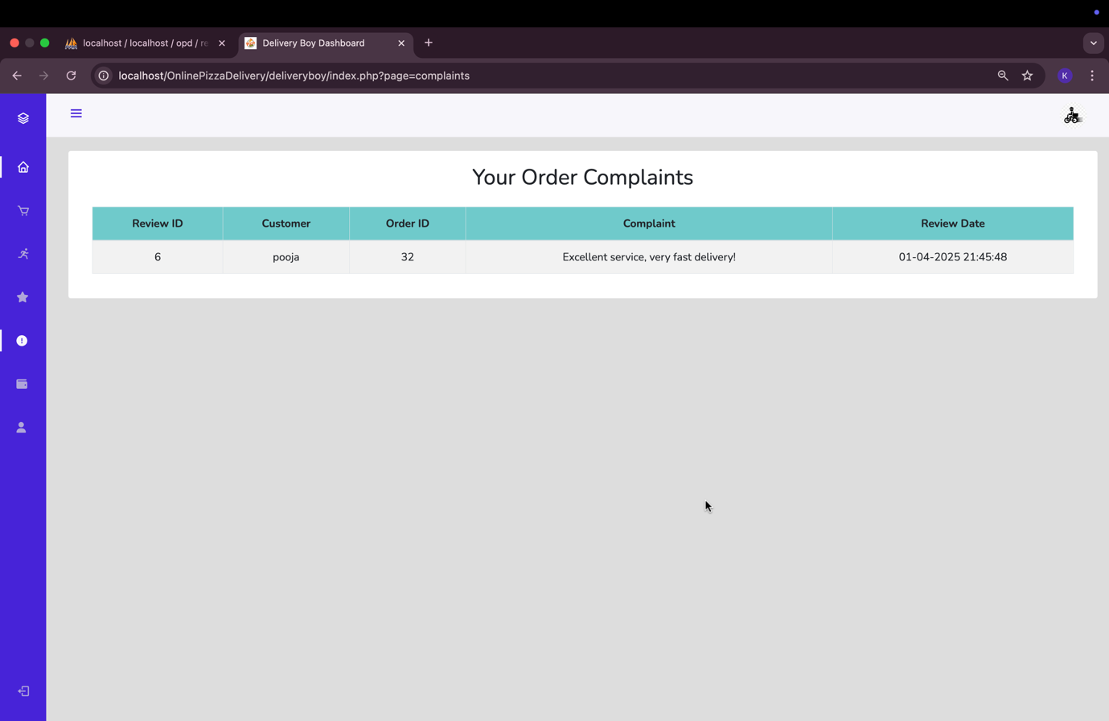

Payouts Per Order:-

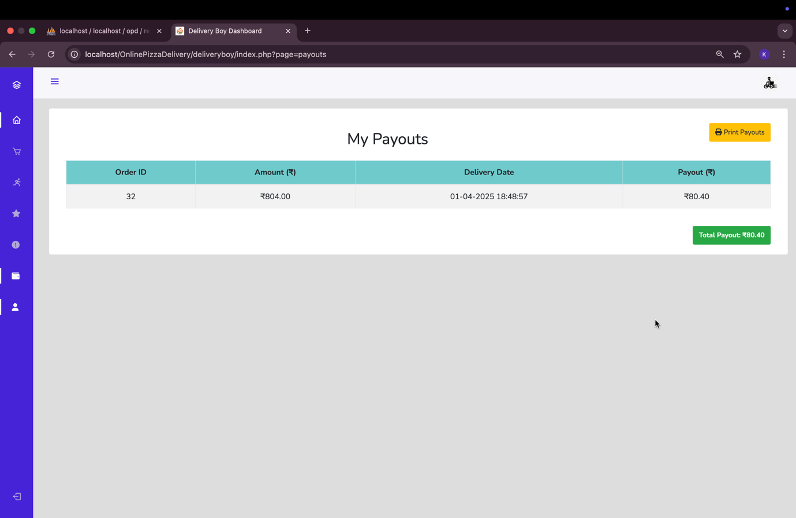

Manage Profile:-

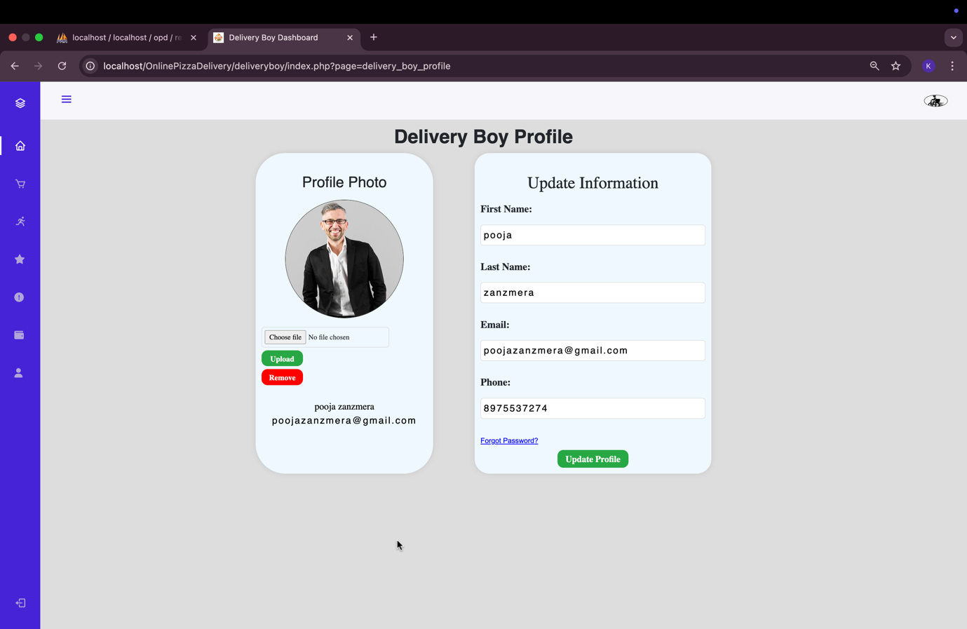

**7**

Chapter

# 7. System Limitation and Future Enhancement

* **System Limitations**

Despite its numerous advantages, the online pizza delivery system has some limitations:

* + **Internet Dependency** – The system requires a stable internet connection for placing and managing orders. Users with slow or no internet access may face difficulties.
  + **Limited Customization** – Some pizza customizations may not be available online compared to in-store ordering.
  + **Delivery Constraints** – The delivery service might be restricted to specific locations, making it inaccessible to users in remote areas.
  + **Technical Glitches** – System errors, payment failures, or server downtime could impact order processing and customer satisfaction.
  + **User Authentication Issues** – If login credentials are forgotten, users may face delays in accessing their accounts.
  + **Real-Time Tracking Limitations** – The system may not always provide accurate real-time tracking updates due to GPS connectivity issues.
  + **High Traffic Management** – The system may slow down or crash during peak hours due to excessive traffic.
  + **Limited Payment Methods** – Some users may prefer cash on delivery, which might not be available in certain cases.
  + **Refund & Cancellation Delays** – Processing refunds or cancellations might take longer, affecting customer trust.
* **Future Enhancements**

To improve and expand the online pizza delivery system, the following future enhancements can be considered:

* + **AI-Based Order Recommendations** – Implement AI-based suggestions for personalized pizza recommendations based on user preferences.
  + **Voice Order Integration** – Allow customers to place orders using voice commands via mobile apps or smart devices.
  + **Drone or Robot Delivery** – Introduce automated drone or robotic delivery for faster and contactless delivery.
  + **Augmented Reality (AR) Menu** – Provide an AR-based menu where customers can visualize their pizza before ordering.
  + **Enhanced Real-Time Tracking** – Improve GPS tracking accuracy for better real-time order tracking.
  + **Loyalty & Reward Programs** – Introduce a loyalty program where frequent customers earn points and receive discounts.
  + **Multilingual Support** – Add language options to make the system accessible to a wider audience.
  + **Cryptocurrency Payment Support** – Integrate cryptocurrency payment options for tech-savvy users.
  + **Eco-Friendly Packaging Option** – Provide users with an option to choose sustainable, eco-friendly packaging.
  + **24/7 Customer Chat Support** – Implement AI-powered chatbots for instant customer assistance.

**8**

Chapter

|  |
| --- |
| 8. References |

|  |  |
| --- | --- |
| 8.1 | Bibliography |
| 8.2 | Webography |

## 8.1 Bibliography

* **"E-Commerce: Business, Technology, Society"** – Kenneth C. Laudon & Carol Guercio Traver
  + Provides insights into online business models, payment gateways, and customer interaction.
* **"Web Development & Design Foundations with HTML, CSS, JavaScript"** – Terry Felke-Morris
  + Covers the technologies used in website development, including front-end and back-end integration.
* **"Database Systems: Design, Implementation, & Management"** – Carlos Coronel, Steven Morris
  + Details about relational databases, SQL queries, and data management.
* **"The Lean Startup"** – Eric Ries
  + Provides methodologies for launching and managing an online business efficiently.
* **Research Paper: "Online Food Ordering Systems & Their Impact on Consumer Behavior"**
  + Discusses the advantages and challenges of online food delivery platforms.

## 8.2 Webography

**Sites URL:-**

* **For PHP**
  + [www.php.net](http://www.php.net)
  + <http://www.w3schools.com/php/>
* **For MySQL**
  + <http://dev.mysql.com/doc>
* **For jQuery and CSS**
  + <http://jquery.com/>
  + <http://css-tricks.com/>
  + <http://cssglobe.com/>
* **For AI**
  + <https://openai.com/chatgpt>
* **For Razorpay**
  + <https://razorpay.com>
  + <https://razorpay.com/docs/>
  + <https://razorpay.com/docs/api/>
  + <https://dashboard.razorpay.com>